**A**

**Project Report**

**On**

**"DOCTOR’S CLINIC DATABASE"**

**Prepared by**

Shashi Bawa (C0700939)

Navneet Kaur (C0711150)

Kirandeep Kaur (C0711489)

Vipanpreet Kaur (C0709156)

Rajinder Singh Giran (C0705279)

**Under the guidance of**

**Prof. David Shenoda**

(Term 1 May 2017- Database and SQL)

Submitted at

**LAMBTON COLLEGE OF ARTS AND TECHNOLOGY**



400-265 Yorkland Blvd Toronto, ONTARIO M2J 1S5

TABLE OF CONTENTS

Acknowledgement ……………………………………………………………………………3

List of Figures …………………………………………………………………………………4

Chapter 1 Introduction

1.1 Introduction to Model 5

1.2 Objective 5

Chapter 2 Implementation of conceptual database modal

2.1 Business Rule 6

2.2 ER Diagram 9

2.3 Relational Database Model 11

Chapter 3 Implementation of physical database modal

3.1 Physical Modal 12

3.2 SQL Queries 35

3,2 SQL Database Views 56

References 62

## ACKNOWLEDGEMENT

Success will not be crowned to people who made it a reality but the people whose constant guidance and encouragement made it possible will be crowned first on the eve of success. The success and final outcome of this project required a lot of guidance and assistance. The constant inspiration, guidance and encouragement by our teacher and all team members led us to the completion of such a good application.

We are grateful to our project guide Prof. David Shenoda for guidance, inspiration and constructive suggestions that help us in preparation of this project.

**LIST OF FIGURES**

Fig 2.1 Entity Relationship Diagram …………………………………………………………... 9

Fig 2.2 Relation Database Model………………………………………………………………. 11

Fig 3.1 Database View ……………………………………….………….……………………… 56

Fig 3.2 Database View …………………………………………….………….…………………. 56

Fig 3.3 Database View …………………………………………….………….………………….. 57

Fig 3.4 Database View ……………………………………………….………….………………. 57

Fig 3.5 Database View ……………………………………………….………….………………. 58

Fig 3.6 Database View ……………………………………………….………….………………. 58

Fig 3.7 Database View ……………………………………………….………….………………. 59

Fig 3.7 Database View ……………………………………………….………….………………. 59

Fig 3.7 Database View ……………………………………………….………….………………. 60

Fig 3.7 Database View ……………………………………………….………….………………. 60

Fig 3.7 Database View ……………………………………………….………….………………. 61

**CHAPTER 1**

**INTRODUCTION**

* 1. **Introduction to model**

Aim of this project is to design and implement a Doctor’s Clinic Database. In this project, a clinic has several doctors who treats patients according to their problems. Each doctor has its own specialty such as General Doctor, Dentist, Cardiology, Orthopedic and many more. It will help patients to book doctor appointments. A prescription may be given by the doctor to patients, using which patients are able to buy medicines and other pharmaceutical stuffs from the clinic’s pharmacy. Clinic’s pharmacy has all the information of its pharmacist. The prescription contains dose, frequency and usage description of medicines for the patients written by doctor. However, a doctor can keep track of patient’s medical history every time the patient visits him.

**1.2 Objective**

* To design and implement a Doctor’s Clinic Database.
* To understand the concepts of Entity-Relationship Model and Normalization.
* To understand and implement all SQL Concepts and Queries.

**CHAPTER 2**

**IMPLEMENTATION OF DOCTOR’S CLINIC DATABASE**

**Case Study: Design and Implementation of a Doctors’ Clinic Database**

**2.1 Business Rules**:

1. The clinic has several doctors
2. Each doctor has a speciality (GP, Cardiology, Pediatrics, Children, etc...)
3. Each patient has a primary doctor
4. Each patient may have several prescriptions (may take several medications)
5. If the patient's primary is not available, then any available doctor might write the prescription to this patient
6. For the Term Project, add the pharmacy's functionality as follow:
   1. The clinic has only one pharmacy
   2. The pharmacy may has one and only one pharmacist
   3. The patient may purchase the medication(s) given in the doctor's prescription(s) from the clinic's pharmacy.

Specify any assumptions you may need to take if you need to

**Requirements**

Stage 1:

1. Identify Entities (Doctor, Specialty, Patient, Prescription, Medication, etc….)
2. Provide the adequate attributes in each entity
3. Clearly identify the relationships between entities, specifying each relationship name
4. Clearly specify the maximum and minimum cardinalities in each relationship
5. All entities and relationships must be at least in the 3rd Normal Form

Stage 2:

1. Build the relational database model for the finalized E-R diagram
2. Using Ms-Access transfer the relation database model into a physical database, this would include:
   1. The specification and selection the appropriate data type and size for each field
   2. The implementation of the primary keys, foreign keys
   3. The creation of the appropriate indexes (if necessary)
3. Populate each table with an adequate number of records (entity instances). At least 25 records in each table. You may use a less number of records in the speciality table not below 7 records
4. Using SQL build the following views (or reports):
   1. The clinic prints and distributes newsletters for its patients who are actively visiting the clinic. Active patients are identified by those who visit the clinic at least twice in the past year
   2. List the number of patients in each medical speciality
   3. List the doctors who work in the clinic sorted in descending order by the number of visits from patients in each month
   4. In a monthly basis, the clinic needs to provide a list of doctors showing how many times a doctor examined a patient during the last month, sorted in descending order by the number of exams
   5. In an annual basis, the clinic needs to provide a list of doctors showing how many times a doctor examined a patient during the last year, sorted in descending order by the number of exams
   6. In a monthly basis, the clinic needs to provide a list of doctors showing how many times a doctor worked in behalf of another doctor during the last month. Sort the list in descending order by the number of times
   7. In an annual basis, the clinic needs to provide a list of doctors showing how many times a doctor worked in behalf of another doctor during the last year. Sort the list in descending order by the number of times
   8. In a monthly basis, the pharmacy needs to get a list of the Medication names sorted in descending order by the number of times it is prescribed by a doctor during the last month
   9. In an annual basis, the pharmacy needs to get a list of the Medication names sorted in descending order by the number of times it is prescribed by a doctor during the last year
   10. In a monthly basis the pharmacy needs to get a list of all medications that are not prescribed during the last month
   11. In an annual basis the pharmacy needs to get a list of all medications that are not prescribed during the last year
   12. Build a list showing how many prescriptions received by the pharmacy for each month starting with the current month and back to the same month last year. i.e. 13 months history
5. Building the Data Entry forms for each entity. Each form should allow insert a new record, update/delete of desired records
6. Build well formatted reports to incorporate the results of all the SQL queries listed above in No 4 above

**2.2 Entities and ER Diagram:**

|  |  |
| --- | --- |
| **ENTITY NAME** |  |
| CLINIC |  |
| DOCTOR |  |
| PATIENT |  |
| PHARMACY |  |
| MEDICATION |  |
| PRESCRIPTION |  |
| APPOINTMENT |  |
| SPECIALITY |  |
| PHARMACIST |  |

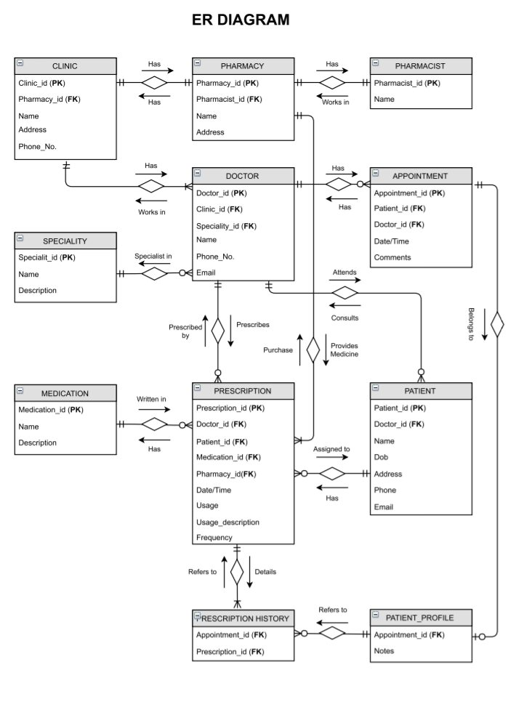

**Fig 2.1 Entity Relationship Diagram**

|  |  |
| --- | --- |
| **ENTITY** | **CARDINALITY** |
| CLINIC-DOCTOR | One Clinic can have Many Doctors |
| DOCTOR-PATIENT | One Doctor can have Many Patients |
| CLINIC-PHARMACY | One Clinic has Only One Pharmacy |
| SPECIALITY-DOCTOR | One Speciality has Many Doctors |
| PHARMACY-PHARMACIST | One Pharmacy has One and only One Pharmacist |
| MEDICATION-PRESCRIPTION | Many Prescriptions are included in Doctor’s One Medication |
| PATIENT-MEDICATION | One Patient can purchase Many Medications from Pharmacy |
| PATIENT-PRESCRIPTION | One Patient can have Many Prescriptions |
| PATIENT-APPOINTMENT | One Patient can make Many Appointments in a Clinic |
| APPOINTMENT-PRESCRIPTION |  |
| PRESCRIPTION-PHARMACY | Medicines from Many Prescriptions are available at Clinic’s One and Only One Pharmacy |

**2.3 RELATIONAL DATABASE MODEL**

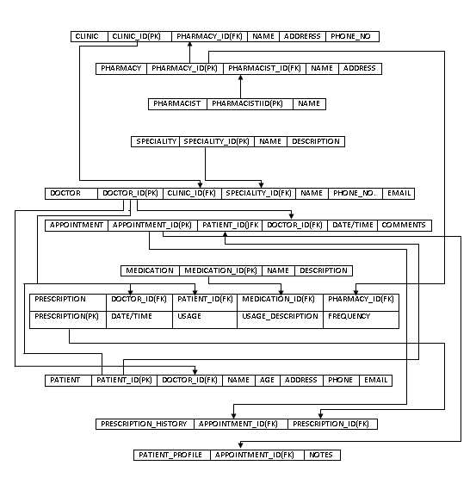

**Fig 2.2** Relational Database Model

**CHAPTER 3**

IMPLEMENTATION OF PHYSICAL DATABASE MODAL

**3.1 PHYSICAL MODEL:**

PHARMACIST

|  |  |
| --- | --- |
| **PHARMACIST_ID** | **NAME** |
| 301 | Inderjit Singh |

PHARMACY

|  |  |  |  |  |
| --- | --- | --- | --- | --- |
| **PHARMACY_ID** | **PHARMACIST_ID** | **NAME** | **ADDRESS** | **FAX** |
| 201 | 301 | Apollo Health Drug Mart | 105 parkway forest drive ON | 000647642 |

CLINIC

|  |  |  |  |  |
| --- | --- | --- | --- | --- |
| **CLINIC_ID** | **PHARMACY_ID** | **NAME** | **ADDRESS** | **PHONE NUMBER** |
| 101 | 201 | Apollo Hospital | 105 Parkway forest drive ON | 6476508871 |

SPECIALITY

|  |  |  |
| --- | --- | --- |
| **SPECIALITY_ID** | **NAME** | **DESCRIPTION** |
| 401 | Cardiologist | Treats and prevents from diseases like Heart and Blood Vessels |
| 402 | Allergist and Immunologist | Diagnoses, treats and manages  Allergies, Asthma and Immunologic Disorder |
| 403 | Addiction Psychiatrist | Focusses on the evaluation, diagnoses and treatment of people who are suffering from one or more disorders related to addiction |
| 404 | Dentist | Focusses on the diagnoses, prevention and treatment of diseases and conditions of the Oral Cavity |
| 405 | Dermatologist | Focuses on the treatment of Skin disorders |
| 406 | Oncologist | Deals with Tumours including the origin, development, diagnosis and treatment of Malignant Neoplasms |
| 407 | General Practitioner | A medical practitioner whose practice is not limited to any specific branch of medicine or class of diseases |
| 408 | ENT Specialist | Treats and diagnosis disorder of the Head, Neck, Ears, Nose and Throat |

DOCTOR

|  |  |  |  |  |  |
| --- | --- | --- | --- | --- | --- |
| **DOCTOR_ID** | **CLINIC_ID** | **SPECIALITY_ID** | **NAME** | **PHONE NUMBER** | **E_MAIL** |
| 501 | 101 | 404 | Kamal Verma | 9055781771 | Kamalverma621@gmail.com |
| 502 | 101 | 407 | John Waters | 9058251032 | Waters.john24@gmail.com |
| 503 | 101 | 401 | Rohit Sharma | 6478211640 | Sharma1099rohit@gmail.com |
| 504 | 101 | 403 | Raj Shirvastav | 9051073462 | Sriraj678@outlook.com |
| 505 | 101 | 404 | Shashi Bawa | 9056531060 | Shashibawa104@gmail.com |
| 506 | 101 | 406 | Marianne Buhler | 6472388164 | Buhler7890mar@gmail.com |
| 507 | 101 | 402 | Michel Daniloski | 6476722496 | Michel1197daniloski@gmail.com |
| 508 | 101 | 405 | Nancy Salzman | 9056731462 | Salzman89nancy@yahoo.com |
| 509 | 101 | 4010 | Dr Salo | 9055148532 | [Salo1995dr@gmail.com](mailto:Salo1995dr@gmail.com) |
| 510 | 101 | 406 | Perrine Gillot | 905864156 | Parrinegillot6220@outlook.com |
| 511 | 101 | 408 | Mark Jones | 01400320000 | [Jones.mark24@gmail.com](mailto:Jones.mark24@gmail.com) |
| 512 | 101 | 402 | Garth Johnson | 2504836018 | Garth678johnson@gmail.com |
| 513 | 101 | 405 | Dr Puja Goyal | 6134249077 | [Goyal1467puja@gmail.com](mailto:Goyal1467puja@gmail.com) |
| 514 | 101 | 403 | Laura Fligg | 9056476511 | [Laurafligg89@yahoo.com](mailto:Laurafligg89@yahoo.com) |
| 515 | 101 | 406 | David Hoffman | 6476511234 | Hoffman.david89@yahoo.com |
| 516 | 101 | 407 | Geoff Rawson | 64798449875 | [Geoffrawson00@gmail.com](mailto:Geoffrawson00@gmail.com) |
| 517 | 101 | 402 | Jim White | 9053333838 | [Jimwhite23@gmail.com](mailto:Jimwhite23@gmail.com) |
| 518 | 101 | 407 | Dr Smith | 9058641560 | [Smith.dr67@gmail.com](mailto:Smith.dr67@gmail.com) |
| 519 | 101 | 407 | Dr Marie Brown | 0142271360 | [Brown.marie245@gmail.com](mailto:Brown.marie245@gmail.com) |
| 520 | 101 | 407 | Dr Juhi Sharma | 0142735110 | [Juhisharma789@gmail.com](mailto:Juhisharma789@gmail.com) |
| 521 | 101 | 404 | Kiran Gupta | 7804847924 | [Kiran.gupta89@gmail.com](mailto:Kiran.gupta89@gmail.com) |
| 522 | 101 | 408 | Sushma Goyal | 905564557 | Goyal.sushma231@gamil.com |
| 523 | 101 | 405 | Dr Veerpal Kaur | 6479216746 | [Veer.kaur567@gmail.com](mailto:Veer.kaur567@gmail.com) |
| 524 | 101 | 407 | Dr Sethi | 9055781557 | [Sethi.89dr@gmail.com](mailto:Sethi.89dr@gmail.com) |
| 525 | 101 | 404 | Aman Grewal | 647592246 | [Grewalaman.89@gmail.com](mailto:Grewalaman.89@gmail.com) |

PATIENT

|  |  |  |  |  |  |  |  |  |  |  |  |  |  |  |
| --- | --- | --- | --- | --- | --- | --- | --- | --- | --- | --- | --- | --- | --- | --- |
| **PATIENT_ID** | | **DOCTOR_ID** | **NAME** | | | **AGE** | | **ADDRESS** | | **PHONE** | | **EMAIL** | **GENDER** | |
| 901 | | 516 | Gurjit kaur | | | 34 | | 65 Mount Ranier crest Brampton ON | | 6474563322 | | Gurjit45@gmail.com | F | |
| 902 | | 502 | Karan singh | | | 21 | | 64 Rosemount drive Scarborough ON | | 4674445522 | | [Karan58@yahoo.com](mailto:Karan58@yahoo.com) | M | |
| 903 | | 519 | Ravinder Singh | | | 68 | | 47 Leith hill road, North York ON | | 9014056732 | | Ravinder8989@gmail.com | M | |
| 904 | | 502 | Raman Gill | | | 45 | | 115 W.Broadway Vancouver, BC, V6J5A4 | | 9014563782 | | [Raman54@gmail.com](mailto:Raman54@gmail.com) | F | |
| 905 | | 507 | Puja Sharma | | | 35 | | 181 bay street suite 3000 Toronto, ON, M5J2T3 | | 6478902435 | | [Puja45@gmail.com](mailto:Puja45@gmail.com) | F | |
| 906 | | 501 | Kiran Kapoor | | | 12 | | 201 Wellington street W.Barrie, ON , L4n5L2 | | 4378998822 | | Kapoorkiran@gmail.com | F | |
| 907 | | 508 | Raj Verma | | | 82 | | 86 York mills road, Toronto ON | | 6478399283 | | [Rajpal565@gmail.com](mailto:Rajpal565@gmail.com) | M | |
| 908 | | 503 | Sukhjinder Singh | | | 46 | | 1 Wexford road Brampton, ON L2F2H1 | | 9102838833 | | [Sukhjinder44@gmail.com](mailto:Sukhjinder44@gmail.com) | M | |
| 909 | | 506 | Laura Hoffman | | | 24 | | 68 forest road, Scarborough, ON | | 4378913744 | | [Laura.hoffman@gmail.com](mailto:Laura.hoffman@gmail.com) | F | |
| 910 | | 505 | Payal modi | | | 75 | | 67 seclusion crest, Brampton On | | 4378787663 | | modiPayal@gmail.com | F | |
| 911 | | 510 | Rohan Kumar | | | 93 | | 67 Dunrankin drive, Missisauga ON | | 6478829283 | | [rohan@gmail.com](mailto:rohan@gmail.com) | M | |
| 912 | | 517 | Komalpreet Kaur | | | 53 | | 797 Princes street, Brampton, ON | | 9103874664 | | [Komal44@gmail.com](mailto:Komal44@gmail.com) | F | |
| 913 | | 511 | Albert mack | | | 67 | | 675 leith hill street, Toronto, ON | | 9017276336 | | [Albert@gmail.com](mailto:Albert@gmail.com) | M | |
| 914 | | 513 | Neha Sharma | | | 24 | | 87 Dufferin road, Toronto, ON | | 4168788875 | | [Sharmaneha44@gmail.com](mailto:Sharmaneha44@gmail.com) | F | |
| 915 | | 512 | Jass Mann | | | 62 | | 98 Dunrankin drive, Missisauga, ON | | 4168999434 | | [Mannjass@gmail.com](mailto:Mannjass@gmail.com) | M | |
| 916 | | 525 | Aman handa | | | 45 | | 67 Forest road, Missisauga, ON | | 2896764564 | | Hunda[Aman@gmail.com](mailto:Aman@gmail.com) | F | |
| 917 | | 522 | Arsh Kumari | | | 82 | | 59 seclusion crest, Missisuaga, ON | | 6747667755 | | [Arsh455@yahoo.com](mailto:Arsh455@yahoo.com) | F | |
| 918 | | 519 | Babal rai | | | 26 | | 76 bay view street, Toronto, ON | | 6046766676 | | [Babal455@gmail.com](mailto:Babal455@gmail.com) | M | |
| 919 | | 514 | Sashi Kapoor | | | 74 | | 23 Amberjack blvd, Scarborough, ON | | 4377656555 | | [Sashi58@gmail.com](mailto:Sashi58@gmail.com) | M | |
| 920 | | 509 | DeepKaran | | | 64 | | 5050 Dufferin street, North York, On | | 4168778785 | | [Deep556@yahoo.com](mailto:Deep556@yahoo.com) | F | |
| 921 | | 520 | Manpreet Kaur | | | 11 | | 7025 Tomken road, Missisauga, ON | | 4698787777 | | [Mandeep@gmail.com](mailto:Mandeep@gmail.com) | F | |
| 922 | | 523 | Kamal Bajava | | | 23 | | 65 Dunrankin drive, ON | | 6476767666 | | [Kamal658@outlook.com](mailto:Kamal658@outlook.com) | F | |
| 923 | | 521 | Preet Dia | | | 33 | | 22 Eglinton avenue, Toronto, ON | | 4677849384 | | [Preet45@gmail.com](mailto:Preet45@gmail.com) | F | |
| 924 | | 524 | Nav Kumar | | | 25 | | 45 Queensdale Avenue E, Hamilton, ON | | 4168374833 | | [Nav89@gmail.com](mailto:Nav89@gmail.com) | M | |
| 925 | | 510 | Dia Palekar | | | 75 | | 55 Bayview villege, Toronto, ON | | 6478377983 | | [palekar55@gmail.com](mailto:palekar55@gmail.com) | F | |
| 926 | | 514 | Pahul Sam | | | 33 | | 99 Fernforest drive, Brampton, ON | | 4014884484 | | [Pahul54@gmail.com](mailto:Pahul54@gmail.com) | M | |
| 927 | | 505 | Joban Atwal | | | 76 | | 85 Alden road, Markham, On | | 4374885894 | | [Joban45@gmail.com](mailto:Joban45@gmail.com) | M | |
| 928 | | 501 | Harry Mann | | | 54 | | 55 Hester street, Hamilton, ON | | 6253745836 | | MannHarry@gmail.com | F | |
| 929 | | 521 | Deepika Sharma | | | **6**3 | | 85 Dudley Avenue, Toronto, ON | | 4164787944 | | Sharmdeepika[@yahoo.com](mailto:David45@yahoo.com) | M | |
| 930 | | 525 | David rock | | | 34 | | 66 Redriver drive, Brampton, ON | | 2019384934 | | David123[@outlook.com](mailto:Manjit55@outlook.com) | M | |
| 931 | 501 | | | Manjit Dhillon | 16 | | 485 Gough road, Markham, ON | | 4168749988 | | [dhiilon @gmail.com](mailto:Liam45@gmail.com) | | | F |
| 932 | 506 | | | Liam peg | 36 | | 556 Kenneth Avenue, North York, ON | | 6475858577 | | liam[@gmail.com](mailto:Emma68@gmail.com) | | | M |
| 933 | 514 | | | Emma roban | 53 | | 88 Ribbon drive, Brampton, ON | | 4188993399 | | [emma@yahoo.com](mailto:emma@yahoo.com) | | | M |
| 934 | 502 | | | William Wat | 74 | | 45 Clegg road, Markham, ON | | 2019293883 | | [Wat.william@gmail.com](mailto:Wat.william@gmail.com) | | | F |
| 935 | 516 | | | Alice | 44 | | 88 Raymal road, Hamilton, ON | | 7489458488 | | [Alice55@gmail.com](mailto:Alice55@gmail.com) | | | M |
| 936 | 501 | | | Jack | 34 | | 369 Barlow road, Markham, ON | | 5878858588 | | [Jack55@gamil.com](mailto:Jack55@gamil.com) | | | M |
| 937 | 518 | | | Avery | 51 | | 669 Olive Avenue, Toronto, ON | | 6777679849 | | [Avery566@gmail.com](mailto:Avery566@gmail.com) | | | F |
| 938 | 505 | | | Sophia | 23 | | 41 Clark blvd, Brampton, ON | | 4775785858 | | [Sophia25@yahoo.com](mailto:Sophia25@yahoo.com) | | | F |
| 939 | 519 | | | Victoria | 74 | | 745 Mortimer Avenue, East York, ON | | 6856895899 | | [Victoria56@outlook.com](mailto:Victoria56@outlook.com) | | | M |
| 940 | 502 | | | Jackson | 26 | | 65 Tomken road, Missisauga, ON | | 4188884857 | | [Jackson545@yahoo.com](mailto:Jackson545@yahoo.com) | | | F |
| 941 | 521 | | | Henry | 34 | | 444 Mutual Street, Toronto, On | | 6138438848 | | [Henry588@yahoo.com](mailto:Henry588@yahoo.com) | | | M |
| 942 | 516 | | | Eva | 54 | | 56 Ward road, Brampton, ON | | 9093283988 | | [Eva555@gmail.com](mailto:Eva555@gmail.com) | | | F |
| 943 | 518 | | | Hunter | 63 | | 654 Whaley Drive, Missisauga,ON | | 6773888388 | | [Hunter568@gmail.com](mailto:Hunter568@gmail.com) | | | M |
| 944 | 505 | | | Julia | 26 | | 36 Eglinton avenue, Toronto, ON | | 3737745788 | | [Julia565@yahoo.com](mailto:Julia565@yahoo.com) | | | F |
| 945 | 520 | | | Like Powed | 66 | | 659 Grand Trunk Avenue, Vaughan, ON | | 9018388477 | | **Likepowed@gmail,com** | | | M |
| 946 | 501 | | | Harper xixen | 37 | | 91 Spar drive, Brampton, ON | | 6373884887 | | **Harper565@gmail** | | | M |
| 947 | 508 | | | Jordon tape | 56 | | 99 Twenty avenue, Hamilton, On | | 4929838885 | | [Jordon55@yahoo.com](mailto:Jordon55@yahoo.com) | | | F |
| 948 | 518 | | | Justin Biber | 64 | | 44 Mohawk road, Hamilton, ON | | 2010988475 | | **Justin55@gmail.com** | | | F |
| 949 | 514 | | | Simon kole | 39 | | 15 Barrhill road, Vaughan, ON | | 6477447848 | | [Simon555@gmail.ocm](mailto:Simon555@gmail.ocm) | | | F |
| 950 | 516 | | | Cole dorex | 27 | | 5454 Deerhurst drive, Brampton, ON | | 6163784886 | | **Coledorex@gmail.com** | | | F |

APPOINTMENT

|  |  |  |  |  |
| --- | --- | --- | --- | --- |
| **APPOINTMENT_ID** | **DATE_TIME** | **DOCTOR_ID** | **PATIENT_ID** | **COMMENTS** |
| 601 | 2015-04-07 10:30:35 | 516 | 901 | Urgent Appointment |
| 602 | 2015-04-09 11:40:36 | 502 | 902 | Routine Checkup |
| 603 | 2015-05-04 12:25:15 | 519 | 903 | General appointment |
| 604 | 2015-05-28 01:03:33 | 502 | 904 | Emergency |
| 605 | 2015-06-07 02:45:00 | 507 | 905 | Walk in Appointment |
| 606 | 2015-06-07 03:35:03 | 501 | 906 | General checkup |
| 607 | 2015-07-26 04:30:01 | 508 | 907 | Periodic Health Exam |
| 608 | 2015-08-14 05:45:19 | 503 | 908 | Physical examination |
| 609 | 2015-09-05 12:30:03 | 506 | 909 | General Checkup |
| 610 | 2015-10-07 11:30:07 | 505 | 910 | Urgent Appointment |
| 611 | 2015-11-25  10:25:33 | 510 | 911 | General Checkup |
| 612 | 2015-12-30 09:55:57 | 517 | 912 | Routine checkup |
| 613 | 2016-01-30 10:15:11 | 511 | 913 | General Checkup |
| 614 | 2016-02-29 04:45:30 | 513 | 914 | Emergency |
| 615 | 2016-03-27 11:30:11 | 512 | 915 | Urgent Appointment |
| 616 | 2016-04-07 12:03:40 | 525 | 916 | Physical Examination |
| 617 | 2016-05-23 10:00:11 | 522 | 917 | Routine checkup |
| 618 | 2016-06-20 12:30:57 | 519 | 918 | Urgent Appointment |
| 619 | 2016-07-17 10:20:55 | 514 | 919 | Emergency |
| 620 | 2016-08-13 09:30:19 | 509 | 920 | Physical Examination |
| 621 | 2016-09-11 10:45:27 | 520 | 921 | General checkup |
| 622 | 2016-10-09 01:30:25 | 523 | 922 | General Checkup |
| 623 | 2016-11-04 03:55:17 | 521 | 923 | Routine Checkup |
| 624 | 2016-12-02 05:30:00 | 524 | 924 | General Checkup |
| 625 | 2016-12-01  06:10:10 | 510 | 925 | Physical Examination |
| 626 | 2017-01-01 10:30:20 | 514 | 926 | Routine Checkup |
| 627 | 2017-01-02 11:30:20 | 505 | 927 | General Checkup |
| 628 | 2017-01-02 12:30:30 | 501 | 928 | Emergency |
| 629 | 2017-01-02 02:30:40 | 521 | 929 | Physical Examination |
| 630 | 2017-02-11 10:30:33 | 525 | 930 | Emergency |
| 631 | 2017-02-14 12:30:44 | 501 | 931 | Physical Examination |
| 632 | 2017-02-18 02:30:34 | 506 | 932 | Routine Checkup |
| 633 | 2017-02-21 03:30:23 | 514 | 933 | General Appointment |
| 634 | 2017-02-23 05:30:12 | 502 | 934 | Walk in appointment |
| 635 | 2017-03-24 11:30:10 | 516 | 935 | Routine Checkup |
| 636 | 2017-03-25  12:30:11 | 501 | 936 | General Appointment |
| 637 | 2017-03-26  1:30:12 | 518 | 937 | Emergency |
| 638 | 2017-03-27  03:30:11 | 505 | 938 | General Appointment |
| 639 | 2017-03-28  04:30:11 | 519 | 939 | Routine Checkup |
| 640 | 2017-04-02 10:15:31 | 502 | 940 | Emergency |
| 641 | 2017-04-03 12:45:54 | 521 | 941 | Routine Checkup |
| 642 | 2017-04-04  02:45:14 | 516 | 942 | Urgent Appointment |
| 643 | 2017-04-30  11:30:19 | 518 | 943 | Routine checkup |
| 644 | 2017-05-01  10:30:05 | 505 | 944 | Urgent Appointment |
| 645 | 2017-05-01  12:25:10 | 520 | 945 | Emergency |
| 646 | 2017-05-05  10:55:15 | 501 | 946 | Routine Checkup |
| 647 | 2017-05-07  10:35:20 | 508 | 947 | General Appointment |
| 648 | 2017-05-11  11:45:25 | 518 | 948 | Urgent Appointment |
| 649 | 2017-05-13  02:15:30 | 514 | 949 | Emergency |
| 650 | 2017-05-18  05:30:45 | 516 | 950 | Routine Checkup |

MEDICATION

|  |  |  |
| --- | --- | --- |
| **MEDICATION_ID** | **NAME** | **DESCRIPTION** |
| 701 | Acetaminophen | Acetaminophen is a pain reliever and a fever reducer. |
| 702 | Adderall | Adderall is used to treat narcolepsy and attention deficit hyperactivity disorder. |
| 703 | Clindamycin | Clindamycin is used to treat serious infections caused by bacteria. |
| 704 | Cyclobenzaprine | Cyclobenzaprine is used to treat skeletal muscle conditions such as pain or injury . |
| 705 | Doxycycline | Doxycycline is used to treat blemishes, bumps, and acne like lesions caused by rosacea. |
| 706 | Gabapentin | Gabapentin is used in adults to treat nerve pain caused by herpes virus or shingles. |
| 707 | Hydrochlorothiazide | Hydrochlorothiazide is used to treat high blood pressure. |
| 708 | Ibuprofen | Reduce fever and treat pain or inflammation caused headache, toothache, back pain, arthritis minor injury. |
| 709 | Lisinopril | Lisinopril is also used to treat congestive heart failure or to improve survival after a heart attack. |
| 710 | Loratadine | Loratadine is used to treat skin hives and itching in people with chronic shin reactions. |
| 711 | Meloxicam | Meloxicam is used to treat pain or inflammation caused by rheumatoid arthritis and osteoarthritis. |
| 712 | Metformin | Metformin is used to improve blood suger control in people with type 2 diabeties |
| 713 | Metoprolol | Treat chest pain and hypertension |
| 714 | Naproxen | Treat pain or inflammation caused by rheumatoid arthritis. |
| 715 | Omeprazole | It is used to treat symptoms of gastroesophageal reflux disease. |
| 716 | Oxycodone | It is used to treat moderate to severe pain. |
| 717 | Pantoprazole | It is used to treat erosive esophagitis. |
| 718 | Prednisone | It is used as an anti inflammatory or an immunosuppressant medication. |
| 719 | Tramadol | *It* is used to treat moderate to severe pain. |
| 720 | Trazodone | It is used treat major dipressive disorder. |
| 721 | Viagra | It is used treat erectile disfunction in men. |
| 722 | Wellbutrin | It treats major depressive disorder and seasonal effective disorder. |
| 723 | Xanax | It is used to treat Anxiety disorders , panic disorder anxity caused by dipression. |
| 724 | Zoloft | It is used to treat depression obessive compulsive disorder, painic disorder , anxiety disorder. |
| 725 | Alprazolam | It is used to treat anxiety disorder , panic disorder and anxiety disorder. |

PRESCRIPTION

|  |  |  |  |  |  |  |  |  |
| --- | --- | --- | --- | --- | --- | --- | --- | --- |
| **PRESCRIPTION_ID** | **DOCTOR_ID** | **PATIENT_ID** | **MEDICATION_ID** | **PHARMACY_ID** | **DATE** | **USAGE** | **USAGE_DESCRIPTION** | **FREQUENCY** |
| 802 | 502 | 902 | 701 | 201 | 2015-04-09 | 1 Tablet | After Meal | 3 Times |
| 803 | 519 | 903 | 703 | 201 | 2015-05-04 | 1 Tablet | Before Meal | 2 Times |
| 804 | 502 | 904 | 705 | 201 | 2015-05-28 | 2 Tablets | Before Meal | 1 Time |
| 805 | 507 | 905 | 707 | 201 | 2015-06-07 | 1 Tablet | Before Meal | 3 Times |
| 806 | 501 | 906 | 709 | 201 | 2015-06-07 | 1 Tablet | After Meal | 2 Times |
| 807 | 508 | 907 | 711 | 201 | 2015-07-26 | 1 Tablet | After Meal | 3 Times |
| 808 | 503 | 908 | 713 | 201 | 2015-08-14 | 1 Tablet | After Meal | 3 Times |
| 809 | 506 | 909 | 715 | 201 | 2015-09-05 | 1 Tablet | After Meal | 3 Times |
| 810 | 505 | 910 | 717 | 201 | 2015-10-07 | 1 Tablet | Before Meal | 2 Times |
| 811 | 510 | 911 | 719 | 201 | 2015-11-25 | 1 Tablet | After Meal | 2 Times |
| 812 | 517 | 912 | 721 | 201 | 2015-12-30 | 2 Tablets | Before Meal | 1 Time |
| 813 | 511 | 913 | 723 | 201 | 2016-01-30 | 1 Tablet | After Meal | 2 Times |
| 814 | 513 | 914 | 725 | 201 | 2016-02-29 | 1 Tablet | Before Meal | 3 Times |
| 815 | 512 | 915 | 702 | 201 | 2016-03-27 | 1 Tablet | Before Meal | 2 Times |
| 816 | 525 | 916 | 704 | 201 | 2016-04-07 | 1 Tablet | After Meal | 2 Times |
| 817 | 522 | 917 | 706 | 201 | 2016-05-23 | 1 Tablet | Before Meal | 2 Times |
| 818 | 519 | 918 | 708 | 201 | 2016-06-20 | 1 Tablet | Before Meal | 1 Time |
| 819 | 514 | 919 | 710 | 201 | 2016-07-17 | 1 Tablet | After Meal | 3 Times |
| 820 | 509 | 920 | 712 | 201 | 2016-08-13 | 1 Tablet | Before Meal | 3 Times |
| 821 | 520 | 921 | 714 | 201 | 2016-09-11 | 1 Tablet | After Meal | 2 Times |
| 822 | 523 | 922 | 716 | 201 | 2016-10-09 | 1 Tablet | After Meal | 1 Time |
| 823 | 521 | 923 | 718 | 201 | 2016-11-04 | 1 Tablet | Before Meal | 2 Times |
| 824 | 524 | 924 | 720 | 201 | 2017-12-02 | 1 Tablet | Before Meal | 2 Times |
| 825 | 510 | 925 | 722 | 201 | 2016-01-01 | 1 Tablet | Before Meal | 3 Times |
| 826 | 514 | 926 | 724 | 201 | 2017-01-01 | 1 Tablet | After Meal | 2 Times |
| 827 | 505 | 927 | 701 | 201 | 2017-01-02 | 1 Tablet | Before Meal | 1 Time |
| 828 | 501 | 928 | 703 | 201 | 2017-01-02 | 1 Tablet | Before Meal | 1 Times |
| 829 | 521 | 929 | 707 | 201 | 2017-02-02 | 1 Tablet | After Meal | 2 Times |
| 830 | 525 | 930 | 709 | 201 | 2017-01-11 | 1 Tablet | Before Meal | 3 Times |
| 831 | 501 | 931 | 711 | 201 | 2017-02-14 | 1 Tablet | After Meal | 2 Times |
| 832 | 506 | 932 | 713 | 201 | 2017-02-18 | 1 Tablet | Before Meal | 2 Times |
| 833 | 514 | 933 | 715 | 201 | 2017-02-28 | 1 Tablet | After Meal | 3 Times |
| 834 | 502 | 934 | 717 | 201 | 2017-02-23 | 1 Tablet | Before Meal | 1 Time |
| 835 | 516 | 935 | 719 | 201 | 2017-03-24 | 1 Tablet | Before Meal | 3 Times |
| 836 | 501 | 936 | 721 | 201 | 2017-03-25 | 1 Tablet | After Meal | 2 Times |
| 837 | 518 | 937 | 723 | 201 | 2017-03-26 | 1 Tablet | After Meal | 2 Times |
| 838 | 505 | 938 | 725 | 201 | 2017-02-27 | 1 Tablet | Before Meal | 2 Times |
| 839 | 519 | 939 | 702 | 201 | 2017-03-28 | 1 Tablet | After Meal | 3 Times |
| 840 | 502 | 940 | 704 | 201 | 2017-04-02 | 1 Tablet | Before Meal | 3 Times |
| 841 | 521 | 941 | 706 | 201 | 2017-4-3 | 1 Tablet | After Meal | 3 Times |
| 842 | 516 | 942 | 708 | 201 | 2017-04-04 | 1 Tablet | Before Meal | 2 Times |
| 843 | 518 | 943 | 710 | 201 | 2017-04-30 | 1 Tablet | After Meal | 1 Time |
| 844 | 505 | 944 | 712 | 201 | 2017-05-01 | 2 Tablets | After Meal | 1 Time |
| 845 | 520 | 945 | 714 | 201 | 2017-05-01 | 1 Tablet | After Meal | 2 Times |
| 846 | 501 | 946 | 716 | 201 | 2017-05-05 | 1 Tablet | Before Meal | 2 Times |
| 847 | 508 | 947 | 718 | 201 | 2017-05-07 | 1 Tablet | After Meal | 2 Times |
| 848 | 518 | 948 | 720 | 201 | 2017-05-11 | 1 Tablet | Before Meal | 2 Times |
| 849 | 514 | 949 | 722 | 201 | 2017-05-13 | 1 Tablet | Before Meal | 3 Times |
| 850 | 516 | 950 | 724 | 201 | 2017-05-18 | 1 Tablet | After Meal | 3 Times |

PRESCRIPTION_HISTORY

|  |  |
| --- | --- |
| **PRESCRIPTION_ID** | **APPOINTMENT_ID** |
| 801 | 601 |
| 802 | 602 |
| 803 | 603 |
| 804 | 604 |
| 805 | 605 |
| 806 | 606 |
| 807 | 607 |
| 808 | 608 |
| 809 | 609 |
| 810 | 610 |
| 811 | 611 |
| 812 | 612 |
| 813 | 613 |
| 814 | 614 |
| 815 | 615 |
| 816 | 616 |
| 817 | 617 |
| 818 | 618 |
| 819 | 619 |
| 820 | 620 |
| 821 | 621 |
| 822 | 622 |
| 823 | 623 |
| 824 | 624 |
| 825 | 625 |
| 826 | 626 |
| 827 | 627 |
| 828 | 628 |
| 829 | 629 |
| 830 | 630 |
| 831 | 631 |
| 832 | 632 |
| 833 | 633 |
| 834 | 634 |
| 835 | 635 |
| 836 | 636 |
| 837 | 637 |
| 838 | 638 |
| 839 | 639 |
| 840 | 640 |
| 841 | 641 |
| 842 | 642 |
| 843 | 643 |
| 844 | 644 |
| 845 | 645 |
| 846 | 646 |
| 847 | 647 |
| 848 | 648 |
| 849 | 649 |
| 850 | 650 |

**3.2 SQL QUERIES:**

create database COMPANY_DB;

use COMPANY_DB;

create table PHARMACIST( PHARMACIST_ID INT PRIMARY KEY,NAME CHAR(20));

insert into PHARMACIST VALUES(00301,'INDERJEET');

create table PHARMACY( PHARMACY_ID INT PRIMARY KEY ,NAME CHAR(10),ADRESS VARCHAR(50),FAX INT,PHARMACIST_ID INT );

insert into PHARMACY VALUES V (00201,'APOLLO HEALTH DRUG MART','105 PARKWAY FOREST Dr ,ON ',000647642,00301);

create table CLINIC(CLINIC_ID INT PRIMARY KEY ,NAME CHAR(20),ADRESS VARCHAR(50),PHARMACY_ID INT);

insert into CLINIC VALUES(00101,'APOLLO HOSPITAL','105 PARKWAY FOREST Dr ,ON ',002010);

create table SPECIALITY(SPECIALITY_ID INT PRIMARY KEY,NAME CHAR(20),DISCRIPTION CHAR(20));

insert into SPECIALITY VALUES(00401,'CARDIOLOGIST','Treats and Prevents from diseases like HEART AND BLOOD VESSELS');

insert into SPECIALITY VALUES(00402,'ALLERGIST AND IMMUNOLOGIST','Diagonoses ,treats and manages allergies ,asthma and immunologic disorders');

insert into SPECIALITY VALUES(00403,'ADDICTION PSYCHIATRIST','Focuses on the evaluation,diagnosis and treatment of people who are suffering from one or more disorders related to addiction');

insert into SPECIALITY VALUES(00404,'DENTIST','Focuses on the diagonosis,prevention and treatment of diseases and conditions of the oral cavity');

insert into SPECIALITY VALUES(00405,'DERMATOLOGIST','Focuses on the treatment of diseases of the skin');

insert into SPECIALITY VALUES(00406,'ONCOLOGIST','Deals with tumors incluing the origin ,development,diagnosis and treatment of malignant neoplasms');

insert into SPECIALITY VALUES(00407,'GENERAL PRACTITIONER','A medical practitioner whose practice is not limited to any specific branch of medicine or class of diseases');

insert into SPECIALITY VALUES(00408,'ENT SPECIALIST','Treats and Diagnosis disorders of the head , neck ,ears , nose and throat');

create table DOCTOR(DOCTOR_ID INT PRIMARY KEY,NAME CHAR(20),EMAIL VARCHAR(50),PHONE INT,SPECIALITY_ID INT,CLINIC_ID INT);

insert into DOCTOR VALUES(00501,'KAMAL VERMA','kamalverma621@gmail.com',9055781771,00405,001010);

insert into DOCTOR VALUES(00502,'JOHN WATERS','waters.jhon24@gmail.com',9058251032,00407,001010);

insert into DOCTOR VALUES(00503,'ROHIT SHARMA','sharma1099rohit@gmail.com',6478211640,00401,001010);

insert into DOCTOR VALUES(00504,'RAJ SRIVASTAV','sriraj67@outlook.com',9051073462,00403,001010);

insert into DOCTOR VALUES(00505,'SHASHI BAWA','shashibawa104@gmail.com',9056531060,00404,001010);

insert into DOCTOR VALUES(00506,'MARIANNE BUHLER','bhuler7890mar@gmail.com',6472388164,00408,001010);

insert into DOCTOR VALUES(00507,'MICHEL DANILOSKI','michel197daniloski@gmail.com',6476722496,00402,001010);

insert into DOCTOR VALUES(00508,'NANCY SALZMAN','salzman89nancy@yahoo.com',9056731462,00405,001010);

insert into DOCTOR VALUES(00509,'DR SALO','salo1995dr@gmail.com',9055148532,00401,001010);

insert into DOCTOR VALUES(00510,'PERRINE GILLOT','perrinegillot6220@outlook.com',905864156,00406,001010);

insert into DOCTOR VALUES(00511,'MARK JONES','jones.mark24@gmail.com',01400320000,00408,001010);

insert into DOCTOR VALUES(00512,'GARTH JOHNSON','garth678johnson@gmail.com',2504836018,00402,001010);

insert into DOCTOR VALUES(00513,'DR.PUJA GOYAL','goyal467puja@gmail.com',6134249077,00405,001010);

insert into DOCTOR VALUES(00514,'LAURA FLIGG','laurafligg89@yahoo.com',9056476511,00403,001010);

insert into DOCTOR VALUES(00515,'DAVID HOFFMAN','hoffman.david89@yahoo.com',6476511234,00406,001010);

insert into DOCTOR VALUES(00516,'GEOFF RAWSON','geoffrawson00@gmail.com',64798449875,00407,001010);

insert into DOCTOR VALUES(00517,'JIM WHITE','jimwhite23@gmail.com',9053333838,00402,001010);

insert into DOCTOR VALUES(00518,'DR.SMITH','smith.dr67@gmail.com',905864156,00407,001010);

insert into DOCTOR VALUES(00519,'DR.MARIE BROWN','brown.marie245@gmail.com',0142271360,00407,001010);

insert into DOCTOR VALUES(00520,'DR.JUHI SHARMA','juhisharma789@gmail.com',0142735110,00407,001010);

insert into DOCTOR VALUES(00521,'KIRAN GUPTA','kiran.gupta89@gmail.com',7804847924,00404,001010);

insert into DOCTOR VALUES(00522,'SUSHMA GOYAL','goyal.sushma231@gmail.com',9055614557,00408,001010);

insert into DOCTOR VALUES(00523,'DR.VEERPAL KAUR','veer.kaur567@gmail.com',6479266746,00405,001010);

insert into DOCTOR VALUES(00524,'DR.SETHI','sethi.89dr@gmail.com',9055781557,00407,001010);

insert into DOCTOR VALUES(00525,'AMAN GREWAL','grewalaman.89@gmail.com',647592246,00404,001010);

create table PATIENT(PATIENT_ID INT PRIMARY KEY,NAME CHAR(20),ADRESS VARCHAR(50),AGE INT,EMAIL VARCHAR(50),PHONE INT,GENDER CHAR(10),DOCTOR_ID INT foreign key);

insert into PATIENT VALUES(00901,'','',34,'',,'F',00516);

insert into PATIENT VALUES(00902,'','',21,'',,'M',00502);

insert into PATIENT VALUES(00903,'','',68,'',,'M',00519);

insert into PATIENT VALUES(00903,'','',68,'',,'M',00519);

insert into PATIENT VALUES(00904,'','',45,'',,'F',00502);

insert into PATIENT VALUES(00905,'','',35,'',,'F',00507);

insert into PATIENT VALUES(00906,'','',12,'',,'F',00501);

insert into PATIENT VALUES(00907,'','',82,'',,'M',00508);

insert into PATIENT VALUES(00908,'','',46,'',,'M',00503);

insert into PATIENT VALUES(00909,'','',24,'',,'F',00506);

insert into PATIENT VALUES(00910,'','',75,'',,'F',00505);

insert into PATIENT VALUES(00911,'','',93,'',,'M',00510);

insert into PATIENT VALUES(00912,'','',53,'',,'F',00517);

insert into PATIENT VALUES(00913,'','',67,'',,'M',00511);

insert into PATIENT VALUES(00914,'','',24,'',,'F',00513);

insert into PATIENT VALUES(00915,'','',62,'',,'M',00512);

insert into PATIENT VALUES(00916,'','',45,'',,'F',00525);

insert into PATIENT VALUES(00917,'','',82,'',,'F',00522);

insert into PATIENT VALUES(00918,'','',26,'',,'M',00519);

insert into PATIENT VALUES(00918,'','',26,'',,'M',00519);

insert into PATIENT VALUES(00919,'','',74,'',,'M',00514);

insert into PATIENT VALUES(00920,'','',64,'',,'F',00509);

insert into PATIENT VALUES(00921,'','',11,'',,'F',00520);

insert into PATIENT VALUES(00922,'','',23,'',,'F',00523);

insert into PATIENT VALUES(00923,'','',33,'',,'F',00521);

insert into PATIENT VALUES(00924,'','',25,'',,'M',00524);

insert into PATIENT VALUES(00925,'','',75,'',,'F',00510);

insert into PATIENT VALUES(00926,'','',33,'',,'M',00514);

insert into PATIENT VALUES(00927,'','',76,'',,'M',00505);

insert into PATIENT VALUES(00928,'','',54,'',,'F',00501);

insert into PATIENT VALUES(00929,'','',63,'',,'M',00521);

insert into PATIENT VALUES(00930,'','',34,'',,'M',00525);

insert into PATIENT VALUES(00931,'','',16,'',,'F',00501);

insert into PATIENT VALUES(00932,'','',36,'',,'M',00506);

insert into PATIENT VALUES(00933,'','',53,'',,'M',00514);

insert into PATIENT VALUES(00934,'','',74,'',,'F',00502);

insert into PATIENT VALUES(00935,'','',44,'',,'M',00516);

insert into PATIENT VALUES(00936,'','',34,'',,'M',00501);

insert into PATIENT VALUES(00937,'','',51,'',,'F',00518);

insert into PATIENT VALUES(00938,'','',23,'',,'F',00505);

insert into PATIENT VALUES(00939,'','',74,'',,'M',00519);

insert into PATIENT VALUES(00940,'','',26,'',,'F',00502);

insert into PATIENT VALUES(00941,'','',34,'',,'M',00521);

insert into PATIENT VALUES(00942,'','',54,'',,'F',00516);

insert into PATIENT VALUES(00943,'','',63,'',,'M',00518);

insert into PATIENT VALUES(00944,'','',26,'',,'F',00505);

insert into PATIENT VALUES(00945,'','',66,'',,'M',00520);

insert into PATIENT VALUES(00946,'','',37,'',,'M',00501);

insert into PATIENT VALUES(00947,'','',56,'',,'F',00508);

insert into PATIENT VALUES(00948,'','',64,'',,'F',00518);

insert into PATIENT VALUES(00949,'','',39,'',,'F',00514);

insert into PATIENT VALUES(00950,'','',27,'',,'F',00516);

create table APPOINTMENT(APPOINTMENT_ID INT PRIMARY KEY,DATE_TIME smalldatetime,DOCTOR_ID INT,PATIENT_ID INT,COMMENTS VARCHAR(50));

insert into APPOINTMENT values (1,'2017-03-19 12:03:40', 1, 1, 'bla bla bla')

insert into APPOINTMENT values (2,'2017-04-23 12:03:40', 1, 2, 'Urget appointment')

insert into APPOINTMENT values (3,'2017-02-19 12:03:40', 2, 3, 'bla bla bla')

insert into APPOINTMENT values (4,'2017-05-23 12:03:40', 2, 4, 'Urget appointment')

insert into APPOINTMENT values (5,'2017-06-19 12:03:40', 1, 1, 'bla bla bla')

insert into APPOINTMENT values (6,'2017-05-23 12:03:40', 1, 2, 'Urget appointment')

insert into APPOINTMENT values (7,'2017-06-19 12:03:40', 3, 6, 'bla bla bla')

insert into APPOINTMENT values (8,'2017-07-23 12:03:40', 3, 5, 'Urget appointment')

select * into COMPANY_DB.APPOINTMENT from APPOINTMENT

insert into APPOINTMENT values (1,'2017-03-19 12:03:40', 1, 1, 'bla bla bla')

insert into APPOINTMENT values (2,'2017-04-23 12:03:40', 1, 2, 'Urget appointment')

insert into APPOINTMENT values (1,'2017-03-19 12:03:40', 1, 1, 'bla bla bla')

insert into APPOINTMENT values (2,'2017-04-23 12:03:40', 1, 2, 'Urget appointment')

insert into APPOINTMENT values (1,'2017-03-19 12:03:40', 1, 1, 'bla bla bla')

insert into APPOINTMENT values (2,'2017-04-23 12:03:40', 1, 2, 'Urgent appointment')

insert into APPOINTMENT values (1,'2017-03-19 12:03:40', 1, 1, 'bla bla bla')

insert into APPOINTMENT values (2,'2017-04-23 12:03:40', 1, 2, 'Urget appointment')

create table MEDICATION(MEDICATION_ID INT PRIMARY KEY,NAME VARCHAR(50),DISCRIPTION VARCHAR(50));

create table PERSCRIPTION(PERSCRIPTION_ID INT PRIMARY KEY,DOCTOR_ID INT,PATIENT_ID INT,DATE_AND_TIME SMALLDATETIME,DOSAGE VARCHAR(50),FREQUENCY VARCHAR(50),USAGE_DESCRIPTION VARCHAR(50),MEDICATION_ID INT);

create table PATIENT_PROFILE(APPOINTMENT_ID INT PRIMARY KEY,NOTES VARCHAR(50));

create table PERSCRIPTION_HISTORY(APPOINTMENT_ID INT PRIMARY KEY,PERSCRIPTION_ID INT);

SELECT * FROM PHARMACY;

CREATE TABLE PHARMACIST(PHARMACIST_ID INT PRIMARY KEY,NAME CHAR(15) NOT NULL);

INSERT INTO PHARMACIST VALUES(301,'INDERJIT SINGH');

SELECT * FROM PHARMACIST;

CREATE TABLE SPECIALITY(SPECIALITY_ID INT PRIMARY KEY,NAME CHAR(30) NOT NULL,DESCRIPTION VARCHAR(70) NOT NULL);

INSERT INTO SPECIALITY VALUES(401,'CARDIOLOGIST','TREATS AND PREVENTS FROM DISEASES LIKE HEART AND BLOOD VESSELS');

INSERT INTO SPECIALITY VALUES(402,'ALLERGIST & IMMUNOLOGIST','DIAGNOSES , TREATS & MANAGES ALLERGIES, ASTHMA & IMMUNOLOGIC DISORDER');

INSERT INTO SPECIALITY VALUES(403,'ADDICTION PSYCHIATRIST','TREATS THE PEOPLE WHO ARE SUFFERING FROM ADDICTION DOSORDERS');

INSERT INTO SPECIALITY VALUES(404,'DENTIS','FOCUSSES ON DIAGNOSIS,PREVENTIO & TREATMENT OF ORAL CAVITY DISEASES');

INSERT INTO SPECIALITY VALUES(405,'DERMATOLOGIST','FOCUSSES ON THE TREATMENT OF SKIN DISORDERS');

INSERT INTO SPECIALITY VALUES(406,'ONCOLOGIST','DEALS WITH TUMOUR INCLUDING THE ORIGIN DIAGNOSIS AND TREATMENT');

INSERT INTO SPECIALITY VALUES(407,'GENERAL PRACTITIONER','TREATS ALL KIND OF DISEASES AND GENERAL HEALTH PROBLEMS');

INSERT INTO SPECIALITY VALUES(408,'ENT SPECIALIST','TREATS AND DIAGNOSIS DISORDER OF HEAD, NECK, EAR, NOSE AND THROAT');

SELECT * FROM SPECIALITY;

CREATE TABLE DOCTOR(DOCTOR_ID INT PRIMARY KEY,CLINIC_ID INT NOT NULL,SPECIALITY_ID INT NOT NULL,NAME CHAR(30) NOT NULL,PHONE VARCHAR(20) NOT NULL,EMAIL VARCHAR(50));

CREATE TABLE DOCTOR(DOCTOR_ID INT PRIMARY KEY,NAME CHAR(20) NOT NULL,EMAIL VARCHAR(50),PHONE VARCHAR(20) NOT NULL,SPECIALITY_ID INT NOT NULL,CLINIC_ID INT NOT NULL);

select *from doctor;

CREATE TABLE APPOINTMENT(APPOINTMENT_ID INT PRIMARY KEY,DOCTOR_ID INT NOT NULL,PATIENT_ID INT NOT NULL, DATETIME smalldatetime NOT NULL DEFAULT CURRENT_TIMESTAMP,COMMENTS VARCHAR(100));

INSERT INTO APPOINTMENT VALUES(601,501,901,'2015-05-07 10:30:51','URGENT APPOINTMENT');

INSERT INTO APPOINTMENT VALUES(602,502,902,'2015-05-08 02:15:01','ROUTINE CHECKUP');

SELECT * FROM medication;

CREATE TABLE MEDICATION (MEDICATION_ID INT PRIMARY KEY,NAME VARCHAR(30) NOT NULL,DESCRIPTION VARCHAR(100) NOT NULL);

INSERT INTO MEDICATION VALUES(701,'Acetaminophen','acetaminophen is a pain reliever and a fever reducer'),

(702,'Amoxicillin','Treat many different types of infection caused by bacteria, such as tonsillitis, bronchitis, pneumonia'),

(702,'Adderall','Adderall is used to treat narcolepsy and attention deficit hyperactivity disorder '),

(703,'Clindamycin','Clindamycin is used to treat serious infections caused by bacteria'),

(704,'Cyclobenzaprine','Cyclobenzaprine is used to treat skeletal muscle conditions such as pain or injury'),

(705,'Doxycycline','Doxycycline is also used to treat blemishes, bumps, and acne-like lesions caused by rosacea.'),

(706,'Gabapentin','Gabapentin is used in adults to treat nerve pain caused by herpes virus or shingles '),

(707,'Hydrochlorothiazide','Hydrochlorothiazide is used to treat high blood pressure'),

(708,'Ibuprofen','Reduce fever and treat pain or inflammation caused headache, toothache, back pain, arthritis minor injury.'),

(709,'Lisinopril','Lisinopril is also used to treat congestive heart failure,or to improve survival after a heart attack.'),

(710,'Loratadine','Loratadine is also used to treat skin hives and itching in people with chronic skin reactions.'),

(711,'Meloxicam','Meloxicam is used to treat pain or inflammation caused by rheumatoid arthritis and osteoarthritis'),

(712,'Metformin','Metformin is used to improve blood sugar control in people with type 2 diabetes.'),

(713,'Metoprolol','Treat angina (chest pain) and hypertension. It is also used to treat or prevent heart attack.'),

(714,'Naproxen','Treats pain or inflammation caused by conditions such as arthritis, ankylosing spondylitis, tendinitis'),

(715,'Omeprazole','Omeprazole is used to treat symptoms of gastroesophageal reflux disease'),

(716,'Oxycodone','Oxycodone is used to treat moderate to severe pain.'),

(717,'Pantoprazole','Pantoprazole is used to treat erosive esophagitis (damage to the esophagus from stomach acid)'),

(718,'Prednisone','Prednisone is used as an anti-inflammatory or an immunosuppressant medication.'),

(719,'Tramadol','Tramadol is used to treat moderate to severe pain.'),

(720,'Trazodone','Trazodone is used to treat major depressive disorder.'),

(721,'Viagra','Viagra is used to treat erectile dysfunction (impotence) in men'),

(722,'Wellbutrin','Wellbutrin treats major depressive disorder and seasonal affective disorder'),

(723,'Xanax','Xanax is used to treat anxiety disorders, panic disorders, and anxiety caused by depression.'),

(724,'Zoloft','Zoloft is used to treat depression, obsessive-compulsive disorder, panic disorder, anxiety disorders'),

(725,'Alprazolam','Alprazolam is used to treat anxiety disorders, panic disorders, and anxiety caused by depression');

DELETE FROM MEDICATION WHERE MEDICATION_ID=701;

DROP TABLE MEDICATION;

select * from PHARMACIST;

INSERT INTO PATIENT VALUES(901,516,'GURJEET KAUR',34,'F','65 Mount Ranier crest Brampton ON',6453728462,'gurjeetkaur@gmail.com');

INSERT INTO PATIENT VALUES

(902,502,'KARAN SINGH',21,'M','64 Rosemount drive Scarborough ON',8647283749,'karansingh@gmail.com'),

(903,519,'RAVINDER SINGH',68,'M','47 Leith hill road, North York ON',6372846382,'ravsingh@gmail.com'),

(904,502,'RAMAN GILL',45,'F','115 W.Broadway Vancouver, BC, V6J5A4',7482937465,'gillraman@gmail.com'),

(905,507,'PUJA SHARMA',35,'F','181 bay street suite 3000 Toronto, ON, M5J2T3 ',6384738374,'psharma@gmail.com'),

(906,501,'KIRAN KAPOOR',12,'F','Wellington street W.Barrie, ON , L4n5L2',8294384938,'kaporkiran@gmail.com'),

(907,508,'RAJAV VERMA',82,'M','86 York mills road, Toronto ON',7482934847,'rajverma@gmail.com'),

(908,503,'SUKHJINDER SINGH',46,'M','1 Wexford road Brampton, ON L2F2H1',7583927348,'sukhsingh@gmail.com'),

(909,506,'LAURA HOFFMAN',24,'F','68 forest road, Scarborough, ON',7482938473,'laurahoff@gmail.com'),

(910,505,'PAYAL MODI',75,'F','67 seclusion crest, Brampton On',9482738472,'modipayal@gmail.com'),

(911,510,'ROHAN KUMAR',93,'M','67 Dunrankin drive, Missisauga ON',7483937444,'rohan@gmail.com'),

(912,517,'KOMAL PREET',53,'F','797 Princes street, Brampton, ON',6573829384,'komalprit@gmail.com'),

(913,511,'ALBERT MACK',67,'M','675 leith hill street, Toronto, ON',6372937848,'albert@gmail.com'),

(914,513,'NEHA SHARMA',24,'F','87 Dufferin road, Toronto, ON',6473829473,'nehasherma@gmail.com'),

(915,512,'JAS MAAN',62,'M','98 Dunrankin drive, Missisauga, ON',6473829473,'maanjas@gmail.com'),

(916,525,'AMAN HANDA',45,'F','67 Forest road, Missisauga, ON',7483927463,'handaaman@gmail.com'),

(917,522,'ARSH KUMARI',82,'F','59 seclusion crest, Missisuaga, ON',8463826738,'arshk@gmail.com'),

(918,519,'BABAL RAI',26,'M','76 bay view street, Toronto, ON',8472837483,'raibabal@gmail.com'),

(919,514,'SASHI KAPOOR',74,'M','23 Amberjack blvd, Scarborough, ON',8473827463,'shashi@gmail.com'),

(920,509,'DEEP KARAN',64,'F','5050 Dufferin street, North York, On',8473827374,'karandeep@gmail.com'),

(921,520,'MANPRIT KAUR',11,'F','7025 Tomken road, Missisauga, ON',8473829473,'manprit@gmail.com'),

(922,523,'KAMAL BAJAVA',23,'F','65 Dunrankin drive, ON',7362846394,'kamal@gmail.com'),

(923,521,'PREET DIA',33,'F','22 Eglinton avenue, Toronto, ON',7382937462,'diaprit@gmail.com'),

(924,524,'NAV KUMAR',25,'M','45 Queensdale Avenue E, Hamilton, ON',7583928563,'nav11@gmail.com'),

(925,510,'DIA PALEKAR',75,'F','55 Bayview villege, Toronto, ON',2643836747,'palekar55@gmail.com'),

(926,514,'PAHUL SAM',33,'M','99 Fernforest drive, Brampton, ON',8593746283,'pahul.sam@gmail.com'),

(927,505,'JOBAN ATWAL',76,'M','85 Alden road, Markham, On',7483746291,'joban_atwal@gmail.com'),

(928,501,'HARRY MAAN',54,'F','55 Hester street, Hamilton, ON',6253745836,'maanharry@gmail.com'),

(929,521,'DEPIKA SHARMA',63,'M','85 Dudley Avenue, Toronto, ON',8372745837,'sharmadepika@gmail.com'),

(930,525,'DAVID ROCK',34,'M','66 Redriver drive, Brampton, ON',8362837463,'david123@gmail.com'),

(931,501,'MANJIT DILHO',16,'F','485 Gough road, Markham, ON',7382947387,'dilho.m@gmail.com'),

(932,506,'LIAM PEG',36,'M','556 Kenneth Avenue, North York, ON',8493829487,'pegliam@gmail.com'),

(933,514,'EMMA ROBAN',53,'M','88 Ribbon drive, Brampton, ON',8593827464,'emma@gmail.com'),

(934,502,'WILLIAM VATT',74,'F','45 Clegg road, Markham, ON',9382937200,'vatt.wiliam@gmail.com'),

(935,516,'NATHAN GIAM',44,'M','88 Raymal road, Hamilton, ON',8003788283,'nathangiam@gmail.com'),

(936,501,'ALICE SEAR',34,'M','369 Barlow road, Markham, ON',9000947736,'alice@gmail.com'),

(937,518,'JACK JONE',51,'F','669 Olive Avenue, Toronto, ON',8887774465,'jackjine@gmail.com'),

(938,505,'AVERY BADR6A',23,'F','41 Clark blvd, Brampton, ON',9998477366,'avery@gmail.com'),

(939,519,'SOFHIA BATRA',74,'M','745 Mortimer Avenue, East York, ON',9888857774,'sofiabatra@gmail.com'),

(940,502,'VICTORIA DE',26,'F','65 Tomken road, Missisauga, ON',9111778883,'de.vic@gmail.com'),

(941,521,'HENRY PRINCE',34,'M','444 Mutual Street, Toronto, On',9111118888,'p.henry@gmail.com'),

(942,516,'EVA TIMY',54,'F','56 Ward road, Brampton, ON',8888333222,'evatim@gmail.com'),

(943,518,'HUNTER HOFIM',63,'M','654 Whaley Drive, Missisauga,ON',9876543210,'hofimhunter@gmail.com'),

(944,505,'JULIA DEES',26,'F','36 Eglinton avenue, Toronto, ON',8765432350,'deesjulia@gmail.com'),

(945,520,'LIKE POWED',66,'M','659 Grand Trunk Avenue, Vaughan, ON',5432109876,'likepowed@gmail.com'),

(946,501,'HARPER SIXEN',37,'M','91 Spar drive, Brampton, ON',8887776655,'sixenharper@gmail.com'),

(947,508,'JORDON TAP',56,'F','99 Twenty avenue, Hamilton, On',6754378954,'jordan@gmail.com'),

(948,518,'JUSTIN BIBER',64,'F','44 Mohawk road, Hamilton, ON',9999911111,'justin.biber@gmail.com'),

(949,514,'SIMON KOLE',39,'F','15 Barrhill road, Vaughan, ON ',7766885544,'simonkole@gmail.com'),

(950,516,'COLE DOREX',27,'F','5454 Deerhurst drive, Brampton, ON',9800008888,'coledorex@gmail.com');

INSERT INTO APPOINTMENT VALUES(601,516,901,2015,04,07,'10:30:35','URGENT APPOINTMENT');

INSERT INTO APPOINTMENT VALUES(602,502,902,2015,04,09,'11:40:36','ROUTINE CHECKUP'),

(603,519,903,2015,05,04,'12:25:15','GENERAL APPOINTMENT'),

(604,502,904,2015,05,28,'01:30:33','EMERGENCY'),

(605,507,905,2015,06,07,'02:45:00','WALK IN APPOINTMENT'),

(606,501,906,2015,06,07,'03:35:03','GENERAL CHECKUP'),

(607,508,907,2015,07,26,'04:30:01','PERIODIC HEALTH EXAM '),

(608,503,908,2015,08,14,'05:45:19','PHYSICAL EXAMINATION'),

(609,506,909,2015,09,05,'12:30:03','GENERAL APPOINTMENT'),

(610,505,910,2015,10,07,'11:30:07','URGENT APPOINTMENT'),

(611,510,911,2015,11,25,'10:25:33','GENERAL CHECKUP'),

(612,517,912,2015,12,30,'09:55:57','ROUTINE CHECKUP'),

(613,511,913,2016,01,30,'10:15:11','GENERAL CHECKUP'),

(614,513,914,2016,02,29,'04:45:30','EMERGENCY'),

(615,512,915,2016,03,27,'11:30:11','URGENT APPOINTMENT'),

(616,525,916,2016,04,07,'02:30:20','PHYSICAL EXAMINATION'),

(617,522,917,2016,05,23,'10:00:11','ROUTINE CHECKUP'),

(618,519,918,2016,06,20,'12:30:57','URGENT APPOINTMENT'),

(619,514,919,2016,07,17,'10:20:55','EMERGENCY'),

(620,509,920,2016,08,13,'09:30:19','PHYSICAL EXAMINATION'),

(621,520,921,2016,09,11,'10:45:27','GENERAL CHECKUP'),

(622,523,922,2016,10,09,'01:30:25','GENERAL CHECKUP'),

(623,521,923,2016,11,04,'03:55:17','ROUTINE CHECKUP'),

(624,524,924,2016,12,02,'05:30:00','GENERAL CHECKUP'),

(625,510,925,2016,12,01,'06:10:10','PHYSICAL EXAMINATION'),

(626,514,926,2017,01,01,'10:30:10','ROUTINE CHECKUP'),

(627,505,927,2017,01,02,'11:30:20','GENERAL CHECKUP'),

(628,501,928,2017,01,02,'12:30:30','EMERGENCY'),

(629,521,929,2017,01,02,'02:30:40','PHYSICAL EXAMINATION'),

(630,525,930,2017,02,11,'10:30:33','EMERGENCY'),

(631,501,931,2017,02,14,'12:30:44','PHYSICAL EXAMINATION'),

(632,506,932,2017,02,18,'02:30:34','ROUTINE CHECKUP'),

(633,514,933,2017,02,21,'03:30:23','GENERAL APPOINTMENT'),

(634,502,934,2017,02,23,'05:30:12','WALK IN APPOINTMENT'),

(635,516,935,2017,03,24,'11:30:10','ROUTINE CHECKUP'),

(636,501,936,2017,03,25,'12:30:11','GENERAL APPOINTMENT'),

(637,518,937,2017,03,26,'01:30:12','EMERGENCY'),

(638,505,938,2017,03,27,'03:30:11','GENERAL APPOINTMENT'),

(639,519,939,2017,03,28,'04:30:11','ROUTINE CHECKUP'),

(640,502,940,2017,04,02,'10:15:31','EMERGENCY'),

(641,521,941,2017,04,03,'12:45:54','ROUTINE CHECKUP'),

(642,516,942,2017,04,04,'02:45:14','URGENT APPOINTMENT'),

(643,518,943,2017,04,30,'11:30:19','ROUTINE CHECKUP'),

(644,505,944,2017,05,01,'10:30:05','URGENT APPOINTMENT'),

(645,520,945,2017,05,01,'12:25:10','EMERGENCY'),

(646,501,946,2017,05,05,'10:55:15','ROUTINE CHECKUP'),

(647,508,947,2017,05,07,'10:35:20','GENERAL APPOINTMENT'),

(648,518,948,2017,05,11,'11:45:25','URGENT APPOINTMENT'),

(649,514,949,2017,05,13,'02:15:30','EMERGENCY'),

(650,516,950,2017,05,18,'05:30:45','ROUTINE CHECKUP');

INSERT INTO PRESCRIPTION VALUES(802,502,902,701,201,2015,4,9,'1 TABLET','3 TIMES','AFTER MEAL'),

(803,519,903,703,201,2015,5,4,'1 TABLET','2 TIMES','BEFORE MEAL'),

(804,502,904,705,201,2015,5,28,'2 TABLETS','1 TIME','BEFORE MEAL'),

(805,507,905,707,201,2015,6,7,'1 TABLET','3 TIMES','BEFORE MEAL'),

(806,501,906,709,201,2015,6,7,'1 TABLET','2 TIMES','AFTER MEAL'),

(807,508,907,711,201,2015,7,26,'1 TABLET','3 TIMES','AFTER MEAL'),

(808,503,908,713,201,2015,8,14,'1 TABLET','3 TIMES','AFTER MEAL'),

(809,506,909,715,201,2015,9,5,'1 TABLET','3 TIMES','AFTER MEAL'),

(810,505,910,717,201,2015,10,7,'1 TABLET','2 TIMES','BEFORE MEAL'),

(811,510,911,719,201,2015,11,25,'1 TABLET','2 TIMES','AFTER MEAL'),

(812,517,912,721,201,2015,12,30,'2 TABLETS','1 TIME','BEFORE MEAL'),

(813,511,913,723,201,2016,1,30,'1 TABLET','2 TIMES','AFTER MEAL'),

(814,513,914,725,201,2016,2,29,'1 TABLET','3 TIMES','BEFORE MEAL'),

(815,512,915,702,201,2016,3,27,'1 TABLET','2 TIMES','BEFORE MEAL'),

(816,525,916,704,201,2016,4,7,'1 TABLET','2 TIMES','AFTER MEAL'),

(817,522,917,706,201,2016,5,23,'1 TABLET','2 TIMES','BEFORE MEAL'),

(818,519,918,708,201,2016,6,20,'1 TABLET','1 TIME','BEFORE MEAL'),

(819,514,919,710,201,2016,7,17,'1 TABLET','3 TIMES','AFTER MEAL'),

(820,509,920,712,201,2016,8,13,'1 TABLET','3 TIMES','BEFORE MEAL'),

(821,520,921,714,201,2016,9,11,'1 TABLET','2 TIMES','AFTER MEAL'),

(822,523,922,716,201,2016,10,9,'1 TABLET','1 TIME','AFTER MEAL'),

(823,521,923,718,201,2016,11,4,'1 TABLET','2 TIMES','BEFORE MEAL'),

(824,524,924,720,201,2016,12,2,'1 TABLET','2 TIMES','BEFORE MEAL'),

(825,510,925,722,201,2016,1,1,'1 TABLET','3 TIMES','BEFORE MEAL'),

(826,514,926,724,201,2017,1,1,'1 TABLET','2 TIMES','AFTER MEAL'),

(827,505,927,701,201,2017,1,2,'1 TABLET','1 TIME','BEFORE MEAL'),

(828,501,928,703,201,2017,1,2,'1 TABLET','1 TIME','BEFORE MEAL'),

(829,521,929,707,201,2017,2,2,'1 TABLET','2 TIMES','AFTER MEAL'),

(830,525,930,709,201,2017,2,11,'1 TABLET','3 TIMES','BEFORE MEAL'),

(831,501,931,711,201,2017,2,14,'1 TABLET','2 TIMES','AFTER MEAL'),

(832,506,932,713,201,2017,2,18,'1 TABLET','2 TIMES','BEFORE MEAL'),

(833,514,933,715,201,2017,2,21,'1 TABLET','3 TIMES','AFTER MEAL'),

(834,502,934,717,201,2017,2,23,'1 TABLET','1 TIME','BEFORE MEAL'),

(835,516,935,719,201,2017,3,24,'1 TABLET','3 TIMES','BEFORE MEAL'),

(836,501,936,721,201,2017,3,25,'1 TABLET','2 TIMES','AFTER MEAL'),

(837,518,937,723,201,2017,3,26,'1 TABLET','2 TIMES','AFTER MEAL'),

(838,505,938,725,201,2017,3,27,'1 TABLET','2 TIMES','BEFORE MEAL'),

(839,519,939,702,201,2017,3,28,'1 TABLET','3 TIMES','AFTER MEAL'),

(840,502,940,704,201,2017,4,2,'1 TABLET','3 TIMES','BEFORE MEAL'),

(841,521,941,706,201,2017,4,3,'1 TABLET','3 TIMES','AFTER MEAL'),

(842,516,942,708,201,2017,4,4,'1 TABLET','2 TIMES','BEFORE MEAL'),

(843,518,943,710,201,2017,4,30,'1 TABLET','1 TIME','AFTER MEAL'),

(844,505,944,712,201,2017,5,1,'2 TABLETS','1 TIME','AFTER MEAL'),

(845,520,945,714,201,2017,5,1,'1 TABLET','2 TIMES','AFTER MEAL'),

(846,501,946,716,201,2017,5,5,'1 TABLET','2 TIMES','BEFORE MEAL'),

(847,508,947,718,201,2017,5,7,'1 TABLET','2 TIMES','AFTER MEAL'),

(848,518,948,720,201,2017,5,11,'1 TABLET','2 TIMES','BEFORE MEAL'),

(849,514,949,722,201,2017,5,13,'1 TABLET','3 TIMES','BEFORE MEAL'),

(850,516,950,724,201,2017,5,18,'1 TABLET','3 TIMES','AFTER MEAL');

INSERT INTO PRESCRIPTION_HISTORY VALUES

(801,601),(802,602),(803,603),(804,604),(805,605),(806,606),(807,607),(808,608),(809,609),(810,610),

(811,611),(812,612),(813,613),(814,614),(815,615),(816,616),(817,617),(818,618),(819,619),(820,620),

(821,621),(822,622),(823,623),(824,624),(825,625),(826,626),(827,627),(828,628),(829,629),(830,630),

(831,631),(832,632),(833,633),(834,634),(835,635), (837,637),(838,638),(839,639),(840,640),(841,641),

(842,642),(843,643),(844,644),(845,645),(846,646),(847,647),(848,648),(849,649),(850,650);

INSERT INTO PATIENT_PROFILE VALUES

(601,''),(602,'-'),(603,'-'),(604,'-'),(605,'-'),(606,'-'),(607,'-'),(608,'-'),(609,'-'),(610,'-'),(611,'-'),(612,'-')

,(613,'-'),(614,'-'),(615,'-'),(616,'-'),(617,'-'),(618,'-'),619,'-'),(620,'-'),(621,'-'),(622,'-'),(623,'-'),(624,'-'),

(625,'-'),(626,'-'),(627,'-'),(628,'-'),(629,'-'),(630,'-'),(631,'-'),(632,'-'),(633,'-'),(634,'-'),(635,'-'),(636,'-'),

(637,'-'),(638,'-'),(639,'-'),(640,'-'),(641,'-'),(642,'-'),(643,'-'),(644,'-'),(645,'-'),(646,'-'),(647,'-'),(648,'-'),

(649,'-'),(650,'-');

SELECT * FROM PRESCRIPTION_HISTORY;

DROP TABLE PRESCRIPTION_HISTORY;

SELECT * FROM PATIENT_PROFILE;

INSERT INTO PRESCRIPTION VALUES(802,502,902,701,201,2015,4,9,'1 TABLET','3 TIMES','AFTER MEAL'),

(803,519,903,703,201,2015,5,4,'1 TABLET','2 TIMES','BEFORE MEAL'),

(804,502,904,705,201,2015,5,28,'2 TABLETS','1 TIME','BEFORE MEAL'),

(805,507,905,707,201,2015,6,7,'1 TABLET','3 TIMES','BEFORE MEAL'),

(806,501,906,709,201,2015,6,7,'1 TABLET','2 TIMES','AFTER MEAL'),

(807,508,907,711,201,2015,7,26,'1 TABLET','3 TIMES','AFTER MEAL'),

(808,503,908,713,201,2015,8,14,'1 TABLET','3 TIMES','AFTER MEAL'),

(809,506,909,715,201,2015,9,5,'1 TABLET','3 TIMES','AFTER MEAL'),

(810,505,910,717,201,2015,10,7,'1 TABLET','2 TIMES','BEFORE MEAL'),

(811,510,911,719,201,2015,11,25,'1 TABLET','2 TIMES','AFTER MEAL'),

(812,517,912,721,201,2015,12,30,'2 TABLETS','1 TIME','BEFORE MEAL'),

(813,511,913,723,201,2016,1,30,'1 TABLET','2 TIMES','AFTER MEAL'),

(814,513,914,725,201,2016,2,29,'1 TABLET','3 TIMES','BEFORE MEAL'),

(815,512,915,702,201,2016,3,27,'1 TABLET','2 TIMES','BEFORE MEAL'),

(816,525,916,704,201,2016,4,7,'1 TABLET','2 TIMES','AFTER MEAL'),

(817,522,917,706,201,2016,5,23,'1 TABLET','2 TIMES','BEFORE MEAL'),

(818,519,918,708,201,2016,6,20,'1 TABLET','1 TIME','BEFORE MEAL'),

(819,514,919,710,201,2016,7,17,'1 TABLET','3 TIMES','AFTER MEAL'),

(820,509,920,712,201,2016,8,13,'1 TABLET','3 TIMES','BEFORE MEAL'),

(821,520,921,714,201,2016,9,11,'1 TABLET','2 TIMES','AFTER MEAL'),

(822,523,922,716,201,2016,10,9,'1 TABLET','1 TIME','AFTER MEAL'),

(823,521,923,718,201,2016,11,4,'1 TABLET','2 TIMES','BEFORE MEAL'),

(824,524,924,720,201,2016,12,2,'1 TABLET','2 TIMES','BEFORE MEAL'),

(825,510,925,722,201,2016,1,1,'1 TABLET','3 TIMES','BEFORE MEAL'),

(826,514,926,724,201,2017,1,1,'1 TABLET','2 TIMES','AFTER MEAL'),

(827,505,927,701,201,2017,1,2,'1 TABLET','1 TIME','BEFORE MEAL'),

(828,501,928,703,201,2017,1,2,'1 TABLET','1 TIME','BEFORE MEAL'),

(829,521,929,707,201,2017,2,2,'1 TABLET','2 TIMES','AFTER MEAL'),

(830,525,930,709,201,2017,2,11,'1 TABLET','3 TIMES','BEFORE MEAL'),

(831,501,931,711,201,2017,2,14,'1 TABLET','2 TIMES','AFTER MEAL'),

(832,506,932,713,201,2017,2,18,'1 TABLET','2 TIMES','BEFORE MEAL'),

(833,514,933,715,201,2017,2,21,'1 TABLET','3 TIMES','AFTER MEAL'),

(834,502,934,717,201,2017,2,23,'1 TABLET','1 TIME','BEFORE MEAL'),

(835,516,935,719,201,2017,3,24,'1 TABLET','3 TIMES','BEFORE MEAL'),

(836,501,936,721,201,2017,3,25,'1 TABLET','2 TIMES','AFTER MEAL'),

(837,518,937,723,201,2017,3,26,'1 TABLET','2 TIMES','AFTER MEAL'),

(838,505,938,725,201,2017,3,27,'1 TABLET','2 TIMES','BEFORE MEAL'),

(839,519,939,702,201,2017,3,28,'1 TABLET','3 TIMES','AFTER MEAL'),

(840,502,940,704,201,2017,4,2,'1 TABLET','3 TIMES','BEFORE MEAL'),

(841,521,941,706,201,2017,4,3,'1 TABLET','3 TIMES','AFTER MEAL'),

(842,516,942,708,201,2017,4,4,'1 TABLET','2 TIMES','BEFORE MEAL'),

(843,518,943,710,201,2017,4,30,'1 TABLET','1 TIME','AFTER MEAL'),

(844,505,944,712,201,2017,5,1,'2 TABLETS','1 TIME','AFTER MEAL'),

(845,520,945,714,201,2017,5,1,'1 TABLET','2 TIMES','AFTER MEAL'),

(846,501,946,716,201,2017,5,5,'1 TABLET','2 TIMES','BEFORE MEAL'),

(847,508,947,718,201,2017,5,7,'1 TABLET','2 TIMES','AFTER MEAL'),

(848,518,948,720,201,2017,5,11,'1 TABLET','2 TIMES','BEFORE MEAL'),

(849,514,949,722,201,2017,5,13,'1 TABLET','3 TIMES','BEFORE MEAL'),

(850,516,950,724,201,2017,5,18,'1 TABLET','3 TIMES','AFTER MEAL');

CREATE TABLE PRESCRIPTION_HISTORY(PRESCRIPTION_ID INT NOT NULL,APPOINTMENT_ID INT NOT NULL);

INSERT INTO PRESCRIPTION_HISTORY VALUES

(801,601),(802,602),](803,603),(804,604),(805,605),(806,606),(807,607),(808,608),(809,609),(811,611),

(812,612),(813,613),(814,614),(815,615),(816,616),(817,617),(818,618),(819,619),(820,620),(821,621),

(822,622),(823,623),(824,624),(825,625),(826,626),(827,627),(828,628),(829,629),(830,630),(831,631),

(832,632),(833,633),(834,634),(835,635),(836,636),(837,637),(838,638),(839,639),(840,640),(841,641),

(842,642),(843,643),(844,644),(845,645),(846,646),(847,647)(848,648),(849,649),(850,650);

CREATE TABLE PATIENT_PROFILE ( APPOINTMENT_ID INT NOT NULL,NOTES VARCHAR(100));

INSERT INTO PATIENT_PROFILE VALUES(601,''),(602,'-'),(603,'-'),(604,'-'),(605,'-'),(606,'-'),(607,'-'),

(608,'-'),(609,'-'),(610,'-'),(611,'-'),(612,'-'),(613,'-'),(614,'-'),(615,'-'),(616,'-'),(617,'-'),(618,'-'),(619,'-'),

(620,'-'),(621,'-'),(622,'-'),(623,'-'),(624,'-'),(625,'-'),(626,'-'),(627,'-'),(628,'-'),(629,'-'),(630,'-'),(631,'-'),

(632,'-'),(633,'-'),(634,'-'),(635,'-'),636,'-'),(637,'-'),(638,'-'),(639,'-'),(640,'-'),(641,'-'),(642,'-'),(643,'-'),

(644,'-'),(645,'-'),(646,'-'),(647,'-'),(648,'-'),(649,'-'),(650,'-');

SELECT DOCTOR_ID,COUNT(PATIENT_ID)AS'EXAM' FROM APPOINTMENT WHERE YEAR=5 GROUP BY DOCTOR_ID ORDER BY COUNT(PATIENT_ID)DESC;

SELECT SPECIALITY.SPECIALITY_ID,COUNT(PATIENT.PATIENT_ID)AS'NUMBER OF PATIENTS' FROM SPECIALITY,PATIENT,DOCTOR WHERE SPECIALITY.SPECIALITY_ID=DOCTOR.SPECIALITY_ID AND DOCTOR.DOCTOR_ID=PATIENT.DOCTOR_ID GROUP BY SPECIALITY.SPECIALITY_ID

SELECT DOCTOR_ID,COUNT(PATIENT_ID)AS VISITS FROM APPOINTMENT GROUP BY DOCTOR_ID ORDER BY COUNT(PATIENT_ID)DESC;

SELECT DOCTOR_ID , COUNT(PATIENT_ID)AS'MASHUR' FROM APPOINTMENT WHERE YEAR=2017 GROUP BY DOCTOR_ID ORDER BY COUNT(PATIENT_ID)DESC;

SELECT*FROM PATIENT_PROFILE;

UPDATE PATIENT_PROFILE SET APPOINTMENT_ID='1' WHERE NOTES=1;

**3.3 SQL DATABASE VIEWS:**

1. The clinic prints and distributes newsletters for its patients who are actively visiting the clinic. Active patients are identified by those who visit the clinic at least twice in the past year.

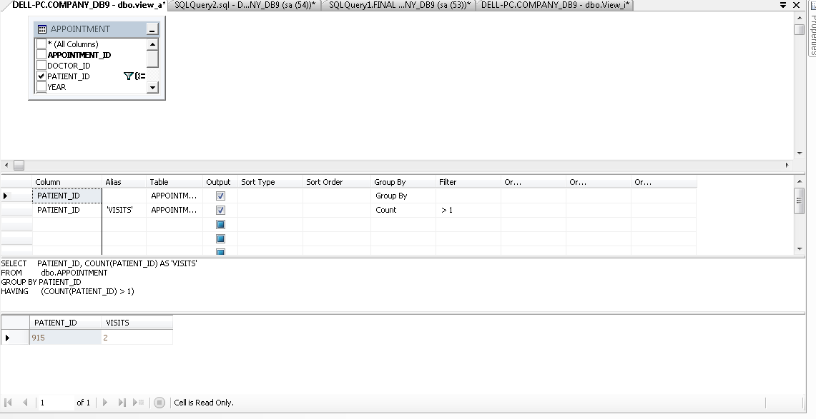

**Fig 3.1** Database View

1. List the number of patients in each medical specialty.

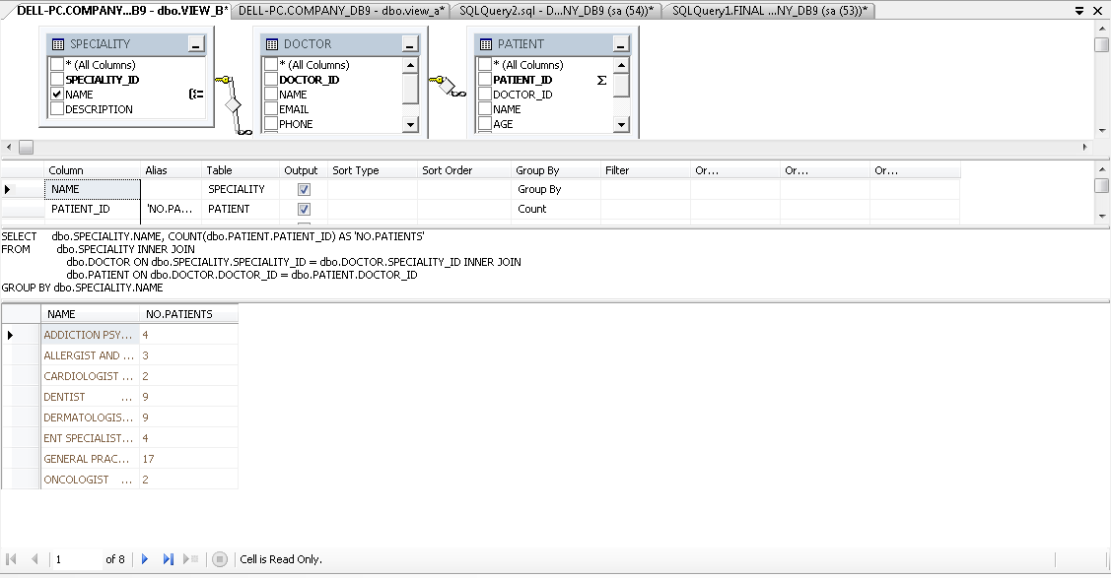

**Fig 3.2** Database View

1. .List the doctors who work in the clinic sorted in descending order by the number of visits from patients in each month.

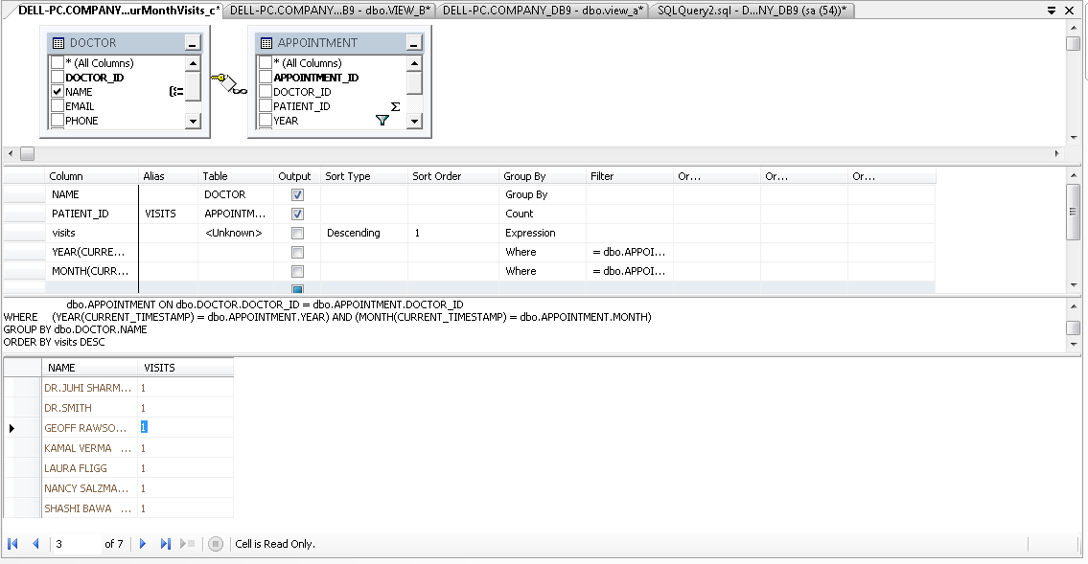

**Fig 3.3** Database View

1. In a monthly basis, the clinic needs to provide a list of doctors showing how many times a doctor examined a patient during the last month, sorted in descending order by the number of exams.

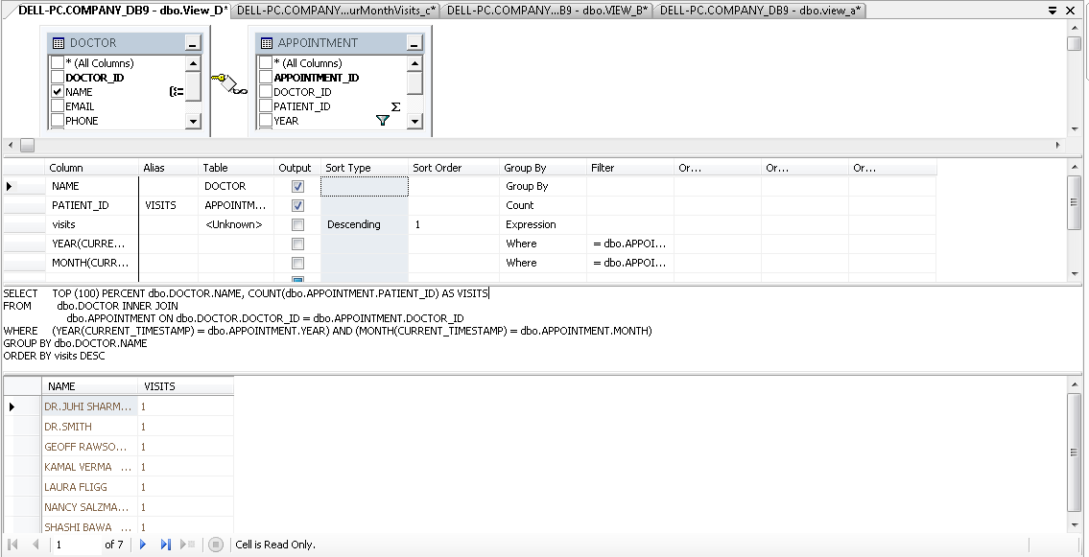

**Fig 3.4** Database View

1. In an annual basis, the clinic needs to provide a list of doctors showing how many times a doctor examined a patient during the last year, sorted in descending order by the number of exams.

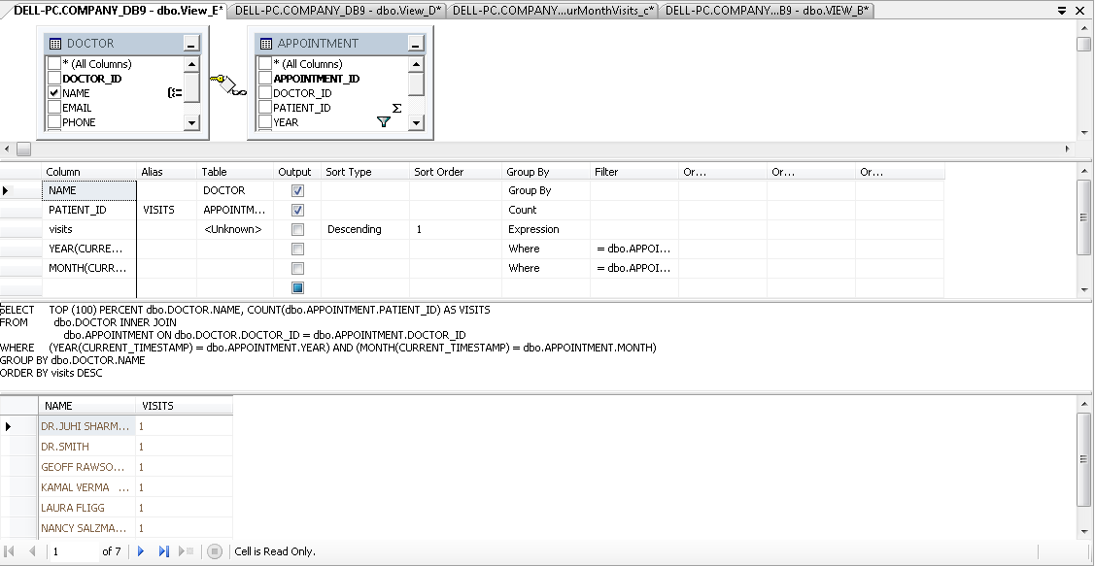

**Fig 3.5** Database View

1. In a monthly basis, the clinic needs to provide a list of doctors showing how many times a doctor worked in behalf of another doctor during the last month. Sort the list in descending order by the number of times

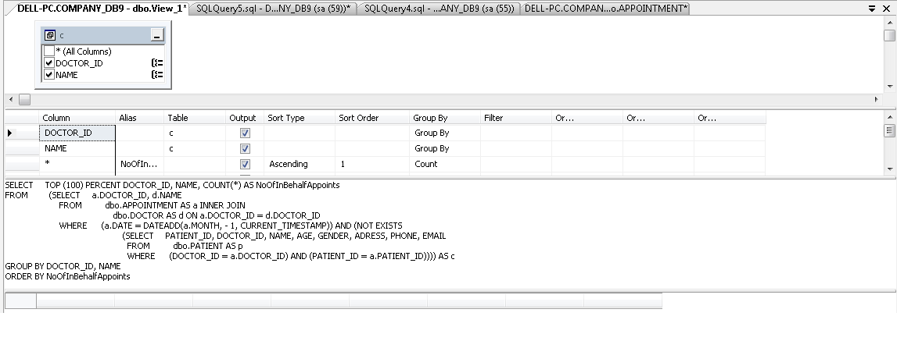

**Fig 3.6** Database View

1. In an annual basis, the clinic needs to provide a list of doctors showing how many times a doctor worked in behalf of another doctor during the last year. Sort the list in descending order by the number of times

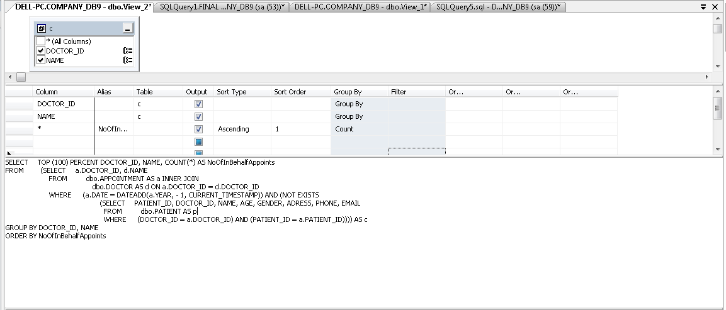

**Fig 3.7** Database View

1. In a monthly basis, the pharmacy needs to get a list of the Medication names sorted in descending order by the number of times it is prescribed by a doctor during the last month.

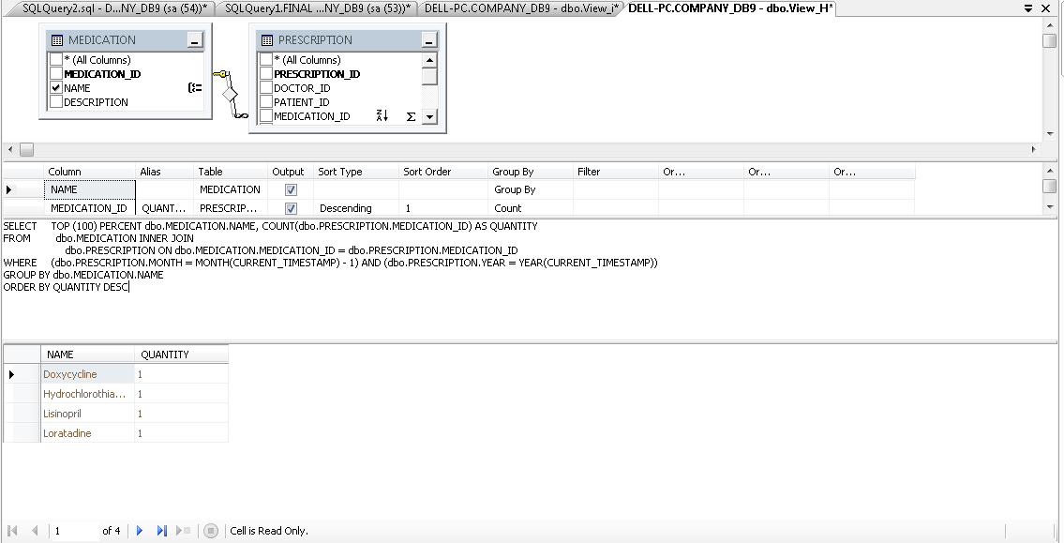

**Fig 3.8** Database View

1. In an annual basis, the pharmacy needs to get a list of the Medication names sorted in descending order by the number of times it is prescribed by a doctor during the last year.

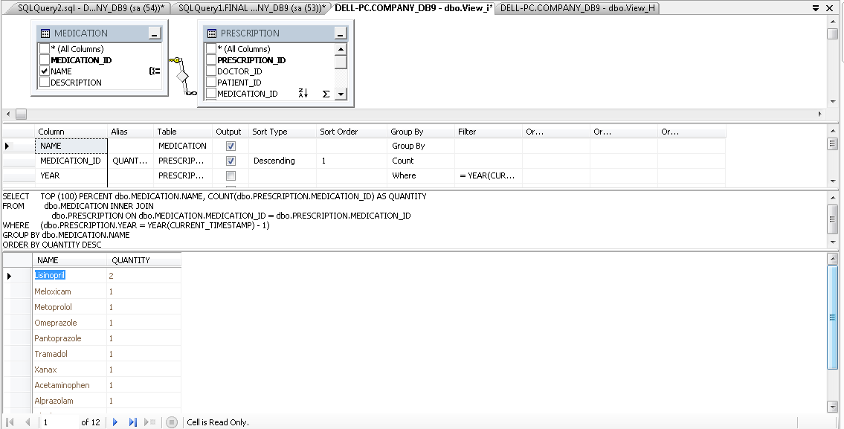

**Fig 3.9** Database View

1. In a monthly basis the pharmacy needs to get a list of all medications that are not prescribed during the last month

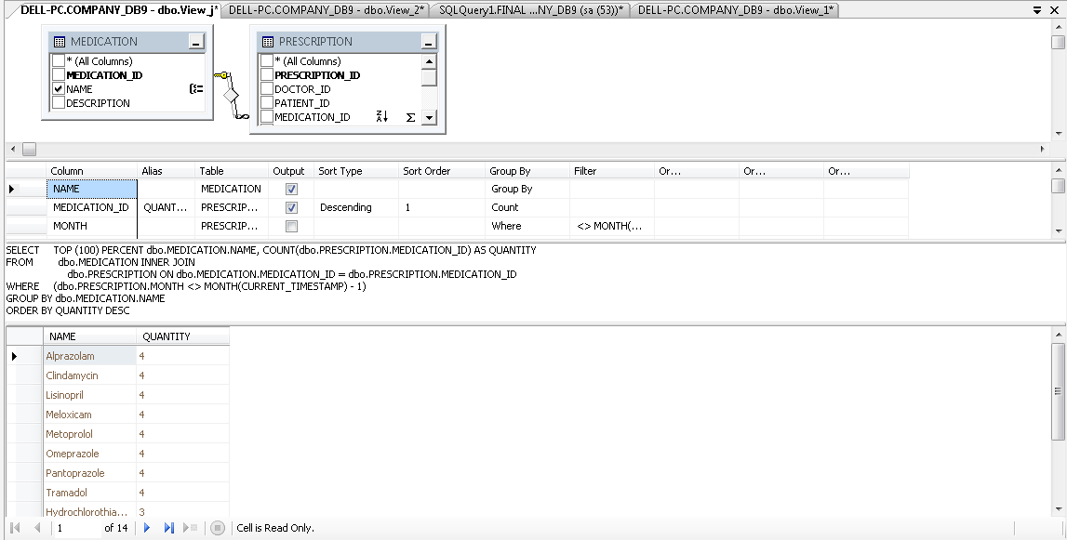

**Fig 3.10** Database View

1. In an annual basis the pharmacy needs to get a list of all medications that are not prescribed during the last year

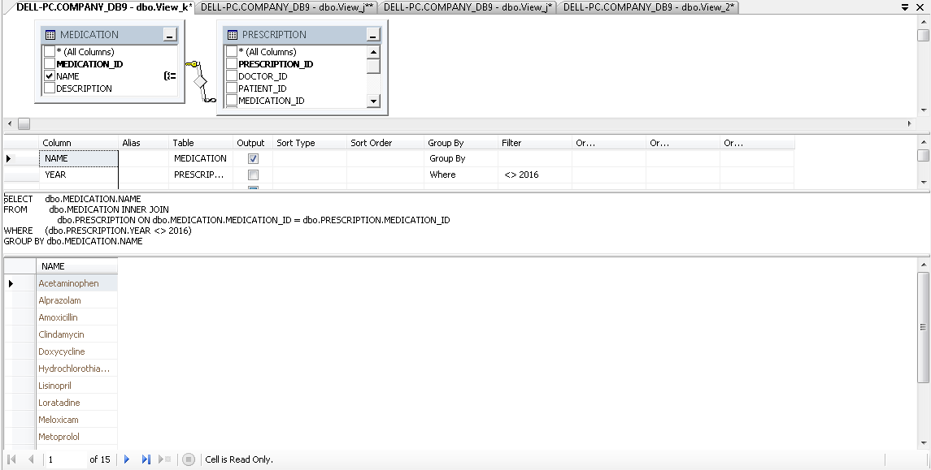

**Fig 3.11** Database View

**REFERENCES:**

<https://www.w3schools.com/sql/>

[**https://www.tutorialspoint.com/sql/**](https://www.tutorialspoint.com/sql/)

[**https://www.youtube.com/watch?v=7Vtl2WggqOg**](https://www.youtube.com/watch?v=7Vtl2WggqOg)

[**https://www.khanacademy.org/computing/computer-programming/sql/**](https://www.khanacademy.org/computing/computer-programming/sql/)